|  |
| --- |
| | **USER MANUAL** | | --- |  | **Document information** | | | --- | --- | | Project Name | Exchange Rate in Billing Document | | Module | SD – Sales and Distribution | | Process | Return | | Created by | Group 7 | | Version | 1.0 | | Date | 20/11/2024 | |
|  |
|  |

| **Change History** | | | | | |
| --- | --- | --- | --- | --- | --- |
| Changed date | Items have been changed | Changed content/Reason | Updated by | Type  (A/C/D) | Version |
| 20/11/2024 | All | First Release | Trang Nguyen  Thu Le | A | 1.0 |
| ***A*** *– Create* ***C*** *– Change* ***D*** *– Delete* | | | | | |

| **Advisor Signature** | | | | |
| --- | --- | --- | --- | --- |
|  | **Full name & Role** | **Signature** | **Date** | **Note** |
| **Created by** | **Trang Nguyen**  [trangntss160256@fpt.edu.vn](mailto:trangntss160256@fpt.edu.vn)  FU - Student  **Thu Le**  [thultbss160283@fpt.edu.vn](mailto:thultbss160283@fpt.edu.vn)  FU - Student |  | 20/11/2024 |  |
| **Reviewed by** | **Phuong Vo**  [phuongvtt1@fpt.com](mailto:phuongvtt1@fpt.com)  FPT Software - Functional Consultant |  | 22/11/2024 |  |
| **Approved by** | **Phuong Vo**  [phuongvtt1@fpt.com](mailto:phuongvtt1@fpt.com)  FPT Software - Functional Consultant |  | 22/11/2024 |  |

| **FU Signature** | | | | |
| --- | --- | --- | --- | --- |
|  | **Full name & Role** | **Signature** | **Date** | **Note** |
| **Reviewed by** | **Giao Nguyen**  [giaonhh@fpt.edu.vn](mailto:giaonhh@fpt.edu.vn)  FU - Lecturer |  |  |  |
| **Approved by** |  |  |  |  |

| **Table of Contents** |
| --- |

**1 OVERVIEW 6**

1.1 The process used in the guide document 6

**2 USER MANUAL 7**

2.1 Context 7

2.2 Create a Return Order 7

*2.2.1 Transaction Code 7*

*2.2.2 Detail Implementation 7*

2.3 Create Return Delivery 12

*2.3.1 Transaction Code 12*

*2.3.2 Detail Implementation 13*

2.4 Post Goods Receipt 14

*2.4.1 Transaction Code 14*

*2.4.2 Detail Implementation 14*

2.5 Remove Billing Block 16

*2.5.1 Transaction Code 16*

*2.5.2 Detail Implementation 16*

2.6 Create Credit Memo 17

*2.6.1 Transaction Code 17*

*2.6.2 Detail Implementation 17*

2.7 Post Credit Memo & Display Accounting Documents 21

*2.7.1 Transaction Code 21*

*2.7.2 Detail Implementation 21*

2.8 Change Credit Memo 24

*2.8.1 Transaction Code 24*

*2.8.2 Detail Implementation 24*

2.9 Post Credit Memo & Display Accounting Documents 27

*2.9.1 Transaction Code 27*

*2.9.2 Detail Implementation 27*

# OVERVIEW

## 1.1 The process used in the guide document

| **BBP No** | **Definition** | **Note** |
| --- | --- | --- |
| SD02 - Return Process | A return process in SAP is a procedure to handle the company’s goods returned by customers. |  |

**Return Process Description:**

The Return Process begins when a customer submits a request to return goods. After evaluating the request, the business decides whether to accept or reject it. If accepted, a sales order return is created in the system to track the return. A delivery document is then generated to manage the physical return of the items, followed by the posting of a goods receipt to update inventory with the returned products. Finally, a credit is created to adjust the customer’s account, either issuing a refund or credit for the returned items. This process ensures proper coordination between sales, logistics, and finance departments for efficient handling of returns.

In the process above, the enhancements which our team develops for the project are:

* Consistent exchange rate type and value, which are used in the Billing Document, are updated exactly from the exchange rate table in T-code OB08, and ensure that they are reflected correctly in the journal entries
* The exchange rate type can correspond until the end of the process
* Set editable for exchange rate field in the Billing Document, allowing it to affect the accounting documents after posting the billing document in the process

# USER MANUAL

## 2.1 Context

**The SAP Return process** entails handling product returns within a company's operations. In other words, a sales return, also known as a goods return, is a procedure where the buyer sends the items back to the seller, who then creates a returns billing document to reimburse the consumer for the value of the goods. The process encompasses steps such as creating return orders (VA01), generating return delivery (VL01N), picking goods (VL01N) and posting goods receipt (VL02N), and creating & changing and posting credit memo (VF01&VF02)*.*

In this project, there are some new enhancements will be released in the system. The new enhancements are the exchange rate type and value can be synchronized correspondingly through the process; the exchange rate field can be updated exactly the value and type from the table in T-code OB08; can be editable in the billing document, and simultaneously, it also affects the accounting documents.

## 2.2 Create a Return Order

### 2.2.1 Transaction Code

| **T-code** | **Description** |
| --- | --- |
| VA01 | Create Sales Documents |
| VA02 | Change Sales Documents |
| VA03 | Display Sales Documents |

### 2.2.2 Detail Implementation

Before going to create the sales order, please go to the *Manage Business Partner Data* app to check the business partner’s exchange rate type:

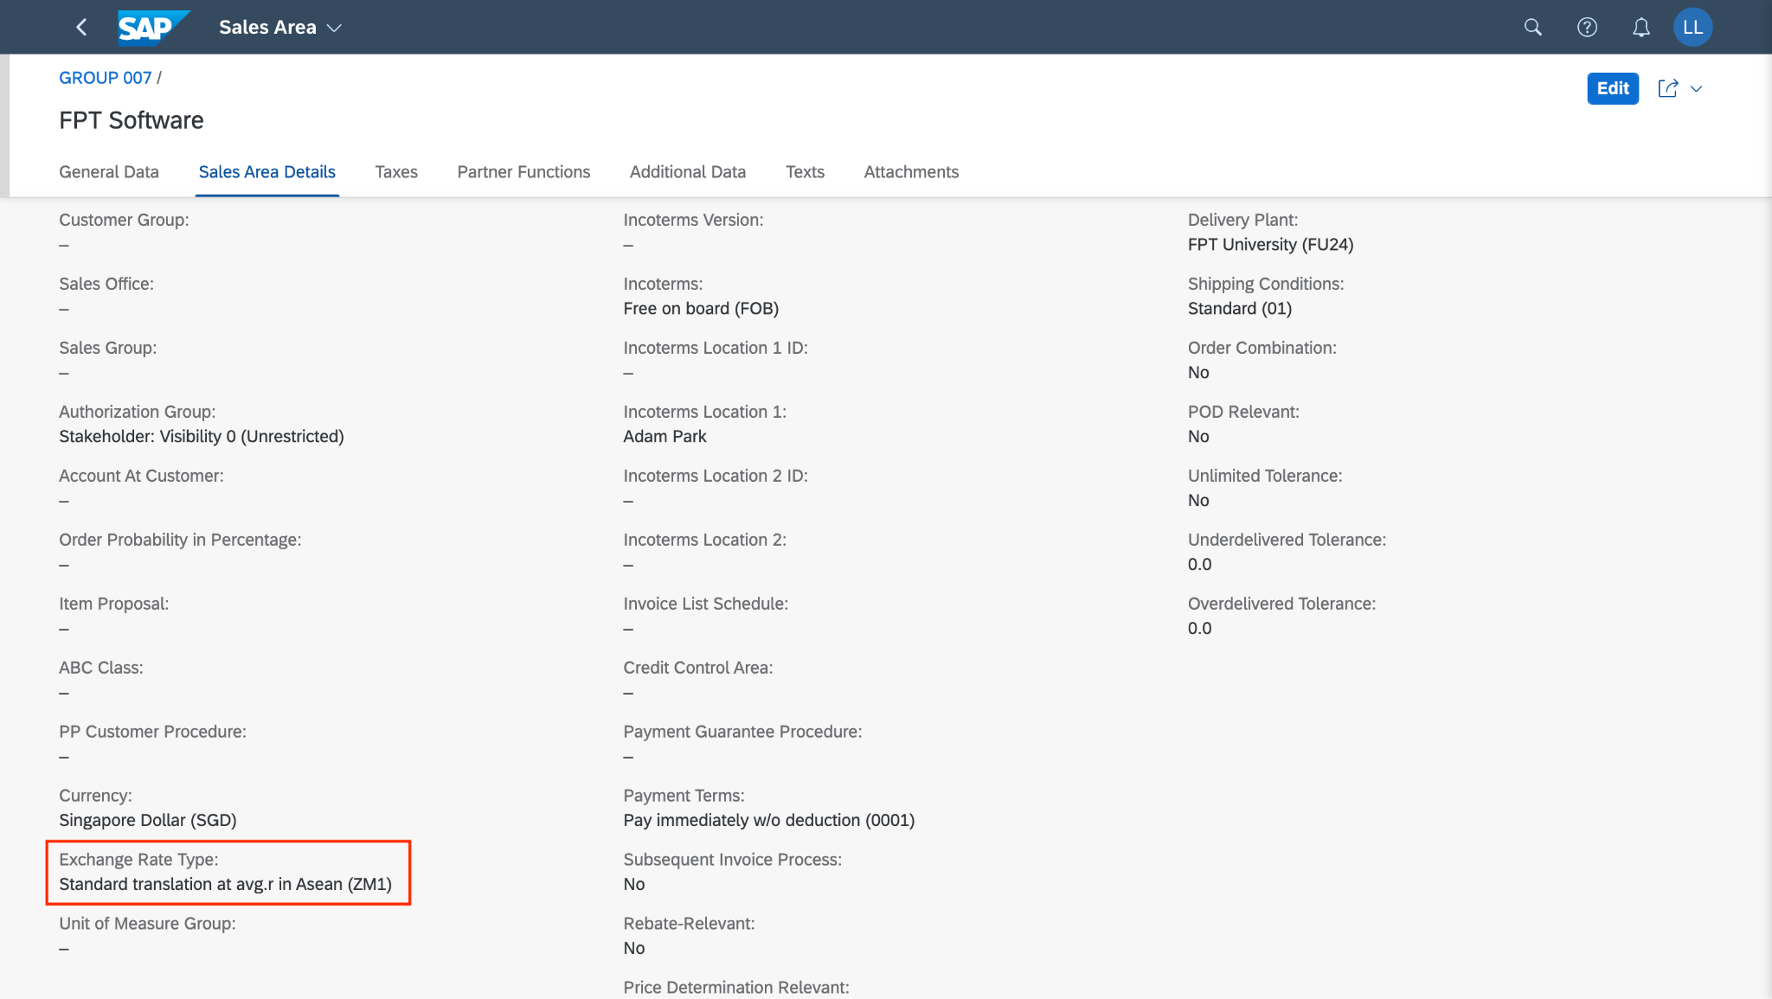

In the space *Sales and Distribution*, and in the section *Sales Representative,* please use the app *Manage Sales Orders* to create a returns order. Click on the application.

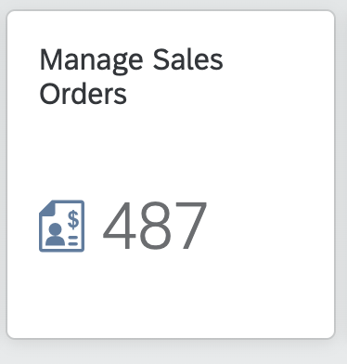

On the *Manage Sales Orders* screen, click on 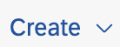 *.* A submenu will open. Choose *Create Sales Order - VA01.*

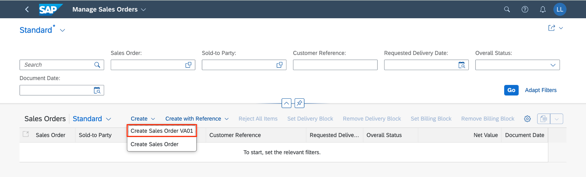

On the *Create Sales Documents* screen, make the following entries:

| **No** | **Field name** | **R/O/D** | **Description and Example** |
| --- | --- | --- | --- |
| 1 | Order Type | R | Choose: **ZRE7** |
| 2 | Sales Organization | R | Default: **FU24** |
| 3 | Distribution Channel | R | Default: **FU** |
| 4 | Division | R | Default: **FD** |

In the lower screen area, click on thebutton.

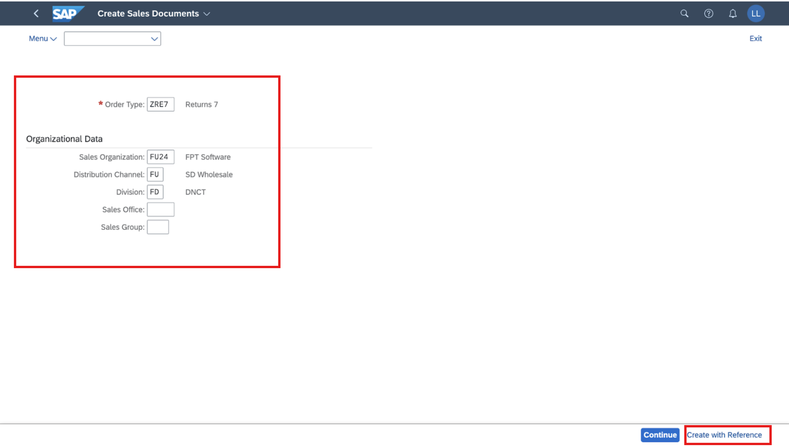

On the *Create with Reference* pop-up, select the *Billing Document* tab, enter **90000420** (The billing document number was created in the stock sales process), then click on **to copy the information from the billing documents to the returns order screen.

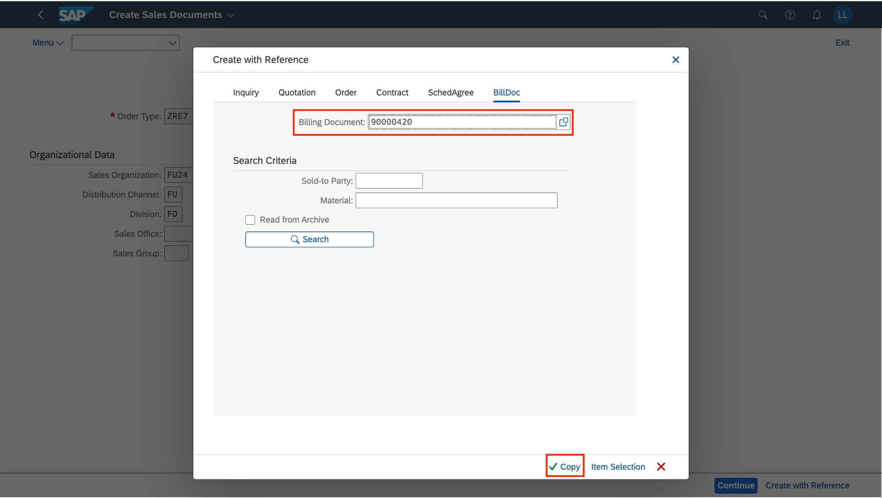

On the *Create Returns 7: Overview screen,* make the following entries:

| **No** | **Field name** | **R/O/D** | **Description** |
| --- | --- | --- | --- |
| 1 | Cust. Reference | O | Customer three-digit number: **215** (your number **###)** |
| 2 | Cust. Ref. Date | O | The date on which the customer created the order: **11/23/2014** |
| 3 | Req. Deliv. date | R | The customer requested a delivery date: **12/23/2024** |
| 4 | Order Reason | R | **102 Damaged in Transit** |

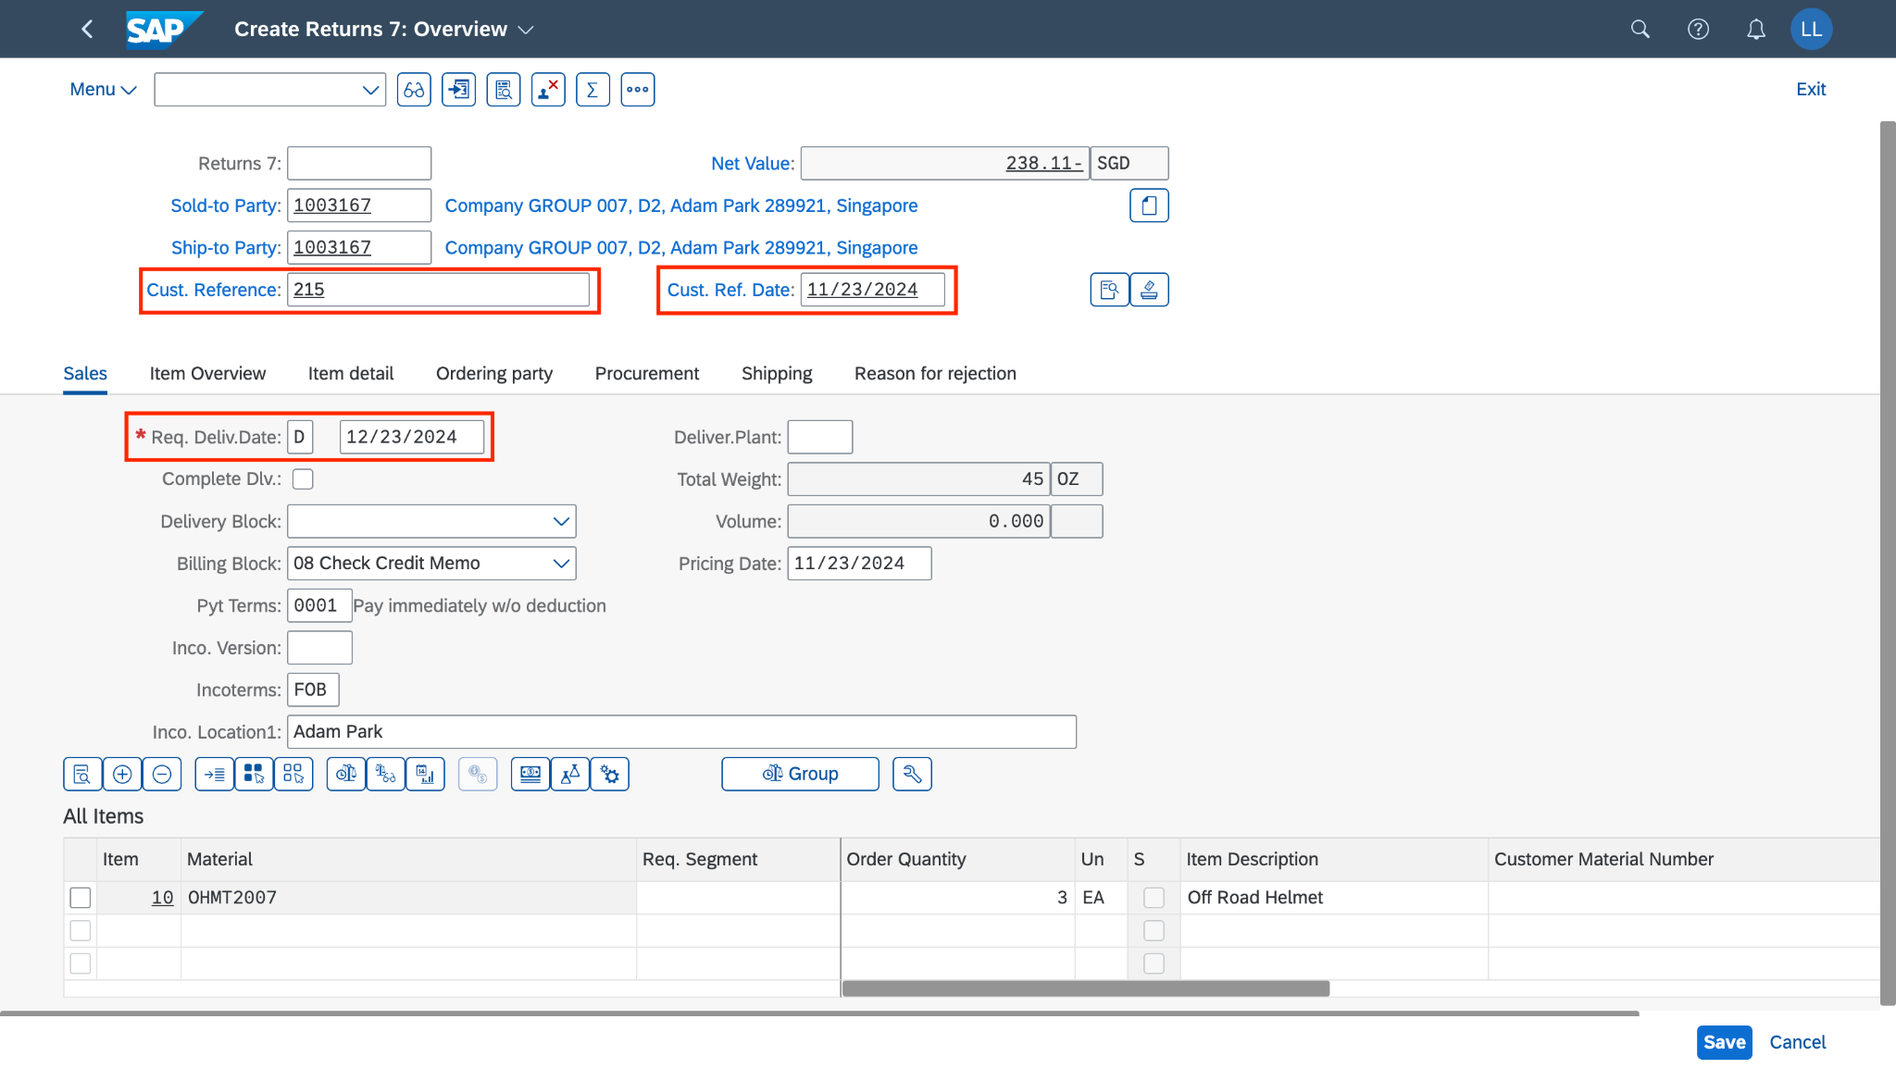

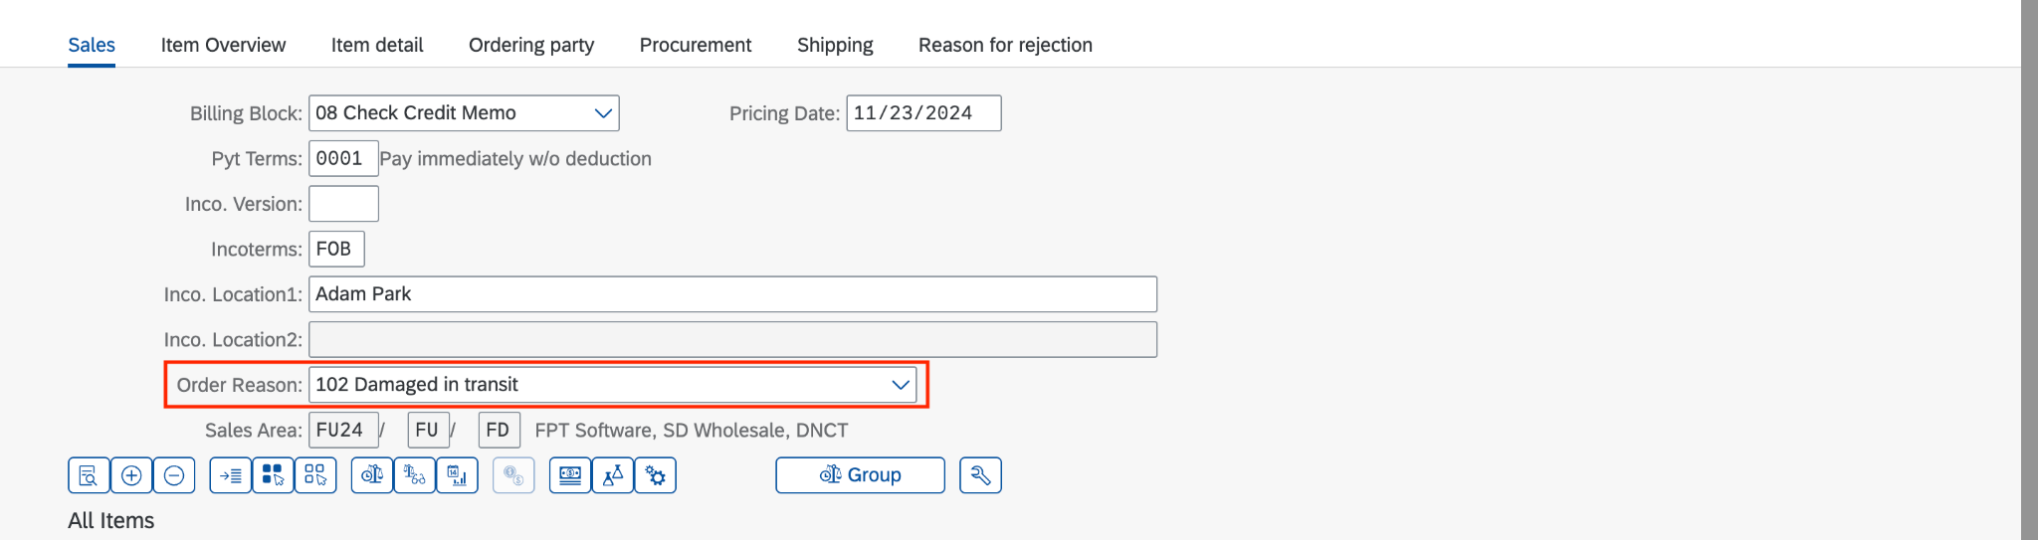

Check the *Incompletion Log* to ensure the document is completed by going to *Menu > Edit > Incompletion Log*.

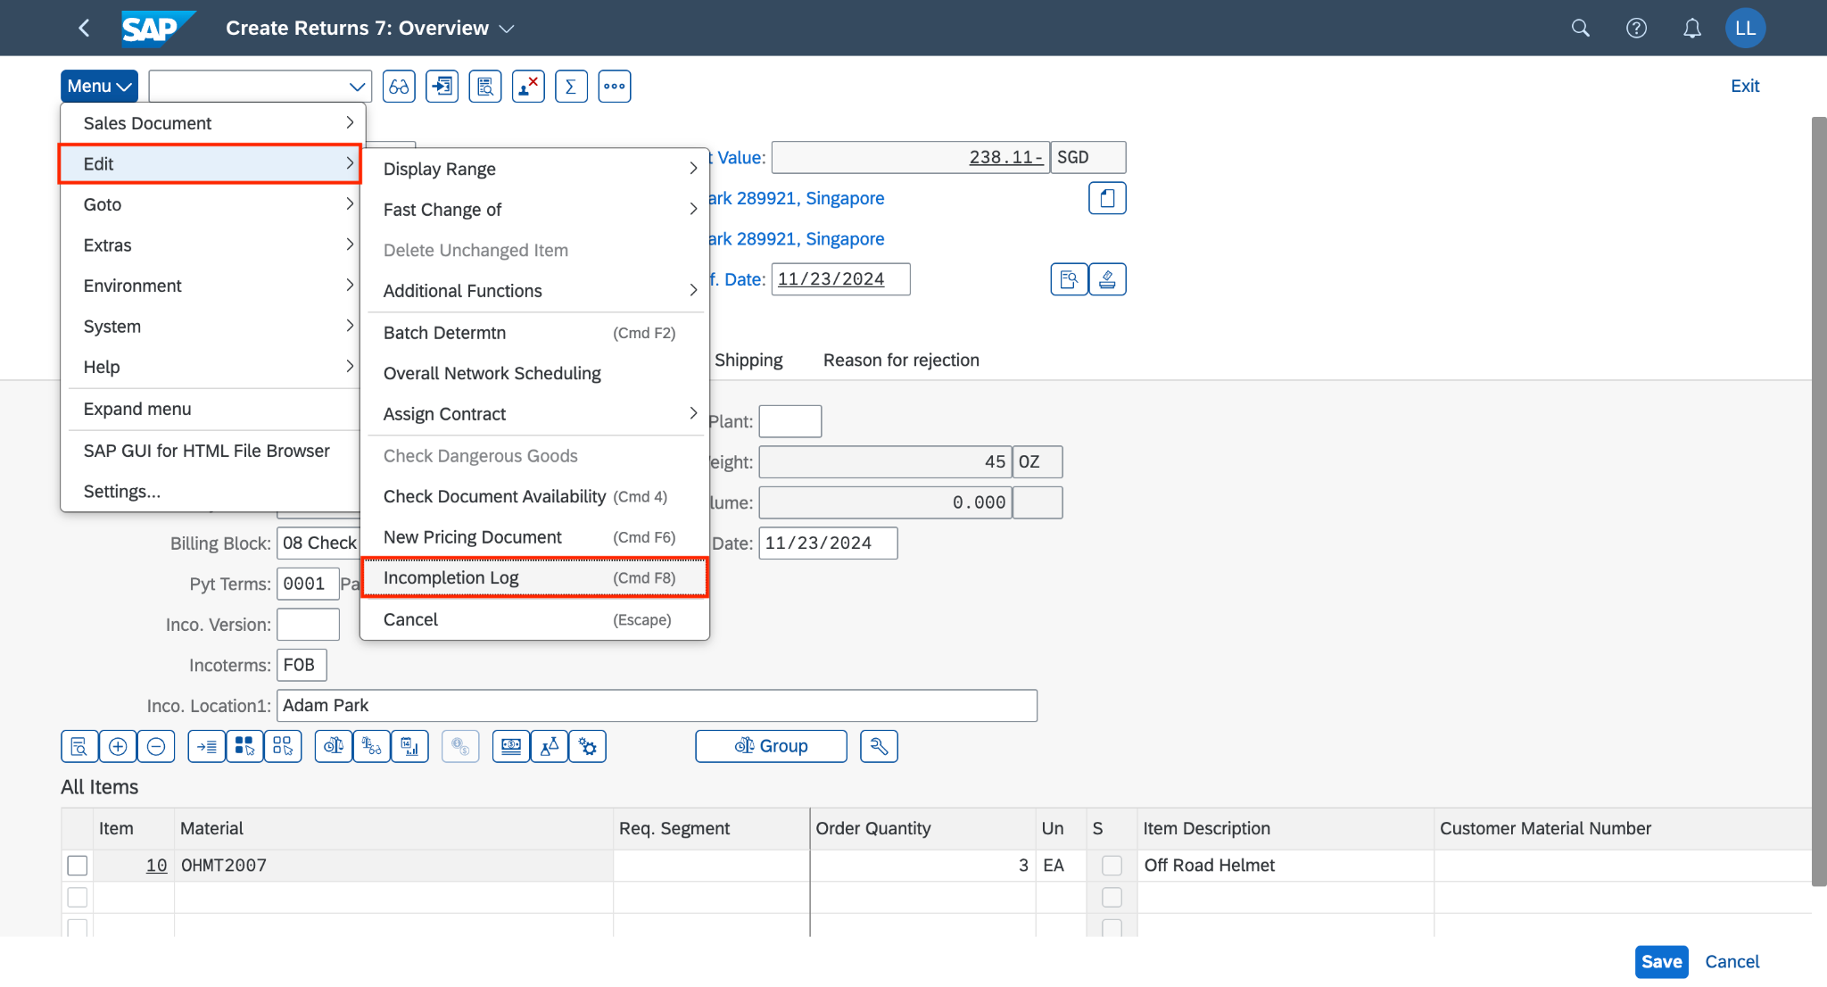

When the document is completed, a small message will pop out to notify:

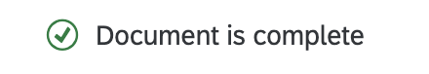

Check the exchange rate and type are updated from the table in T-code OB08 by going to *Menu > Goto > Header > Sales.*

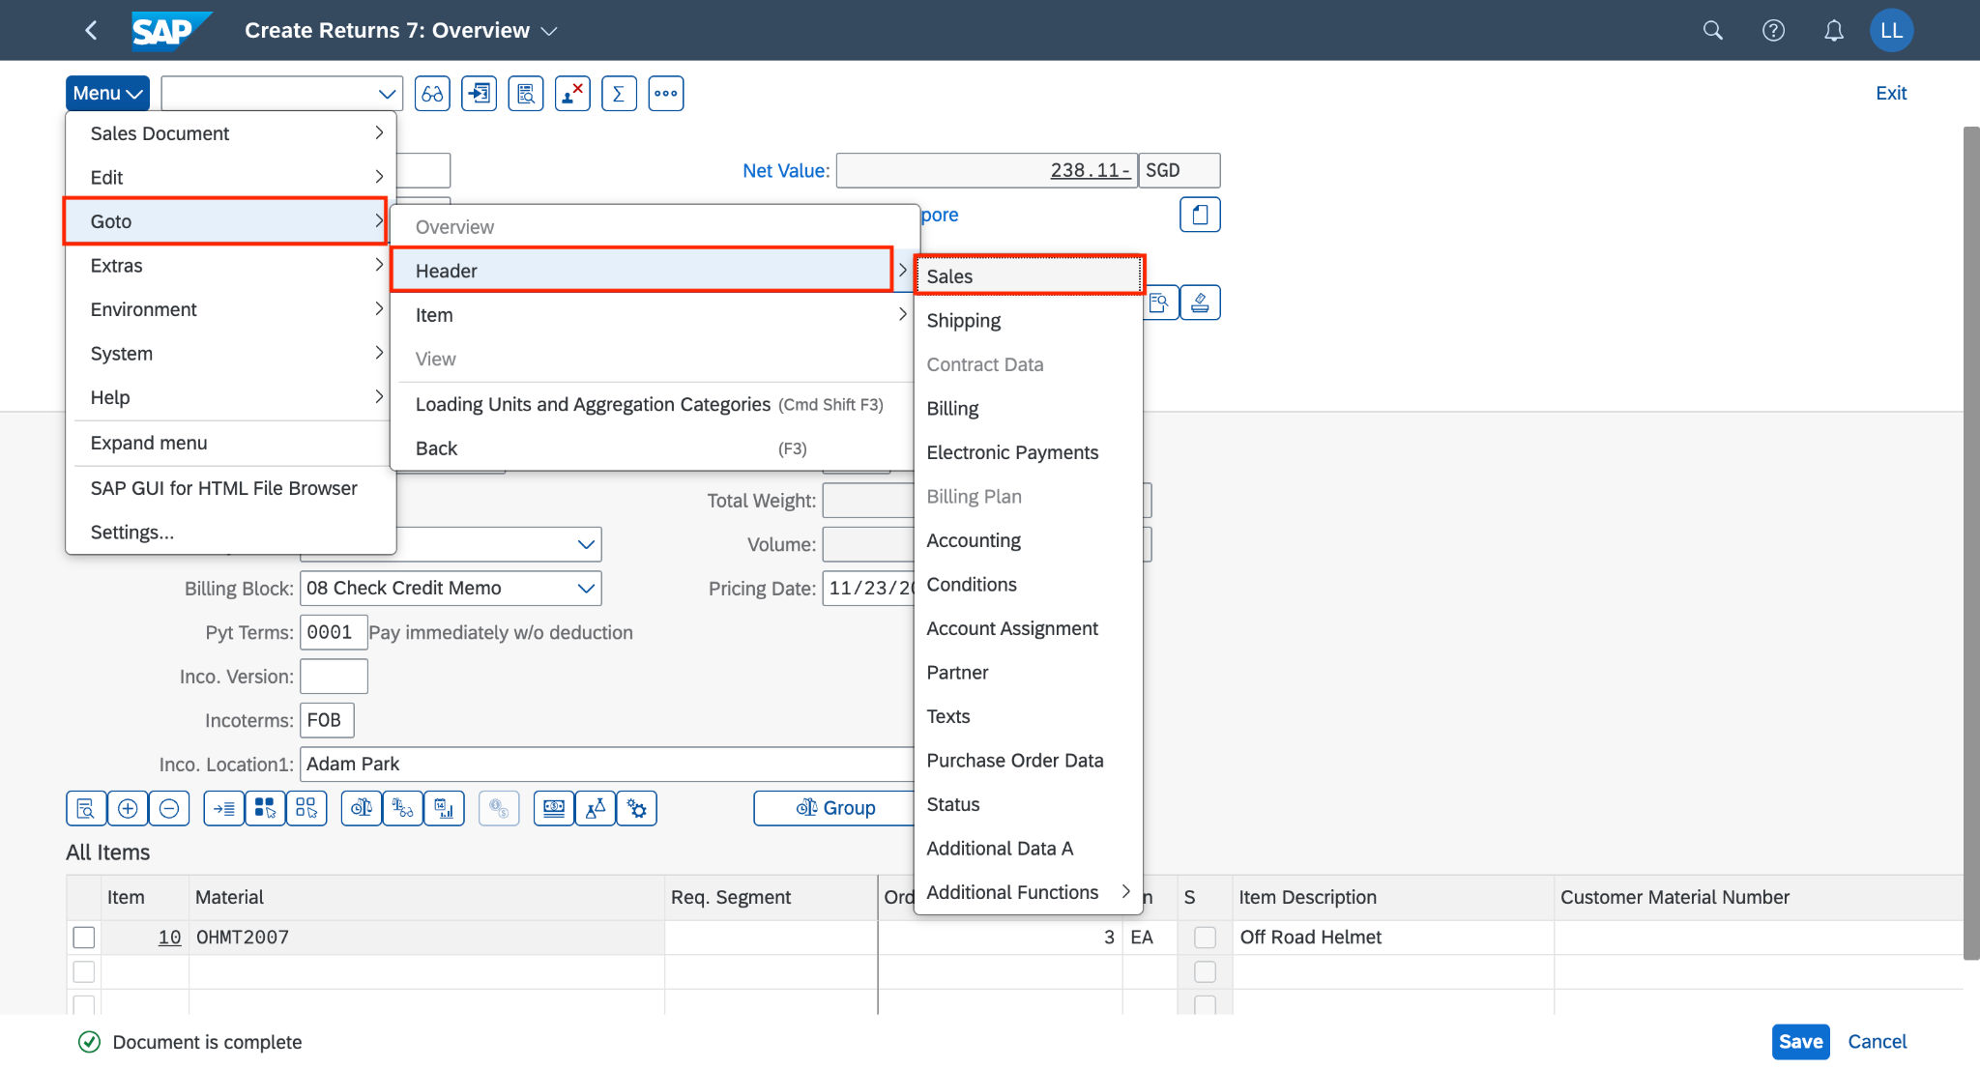

You can see that the exchange rate value and type:

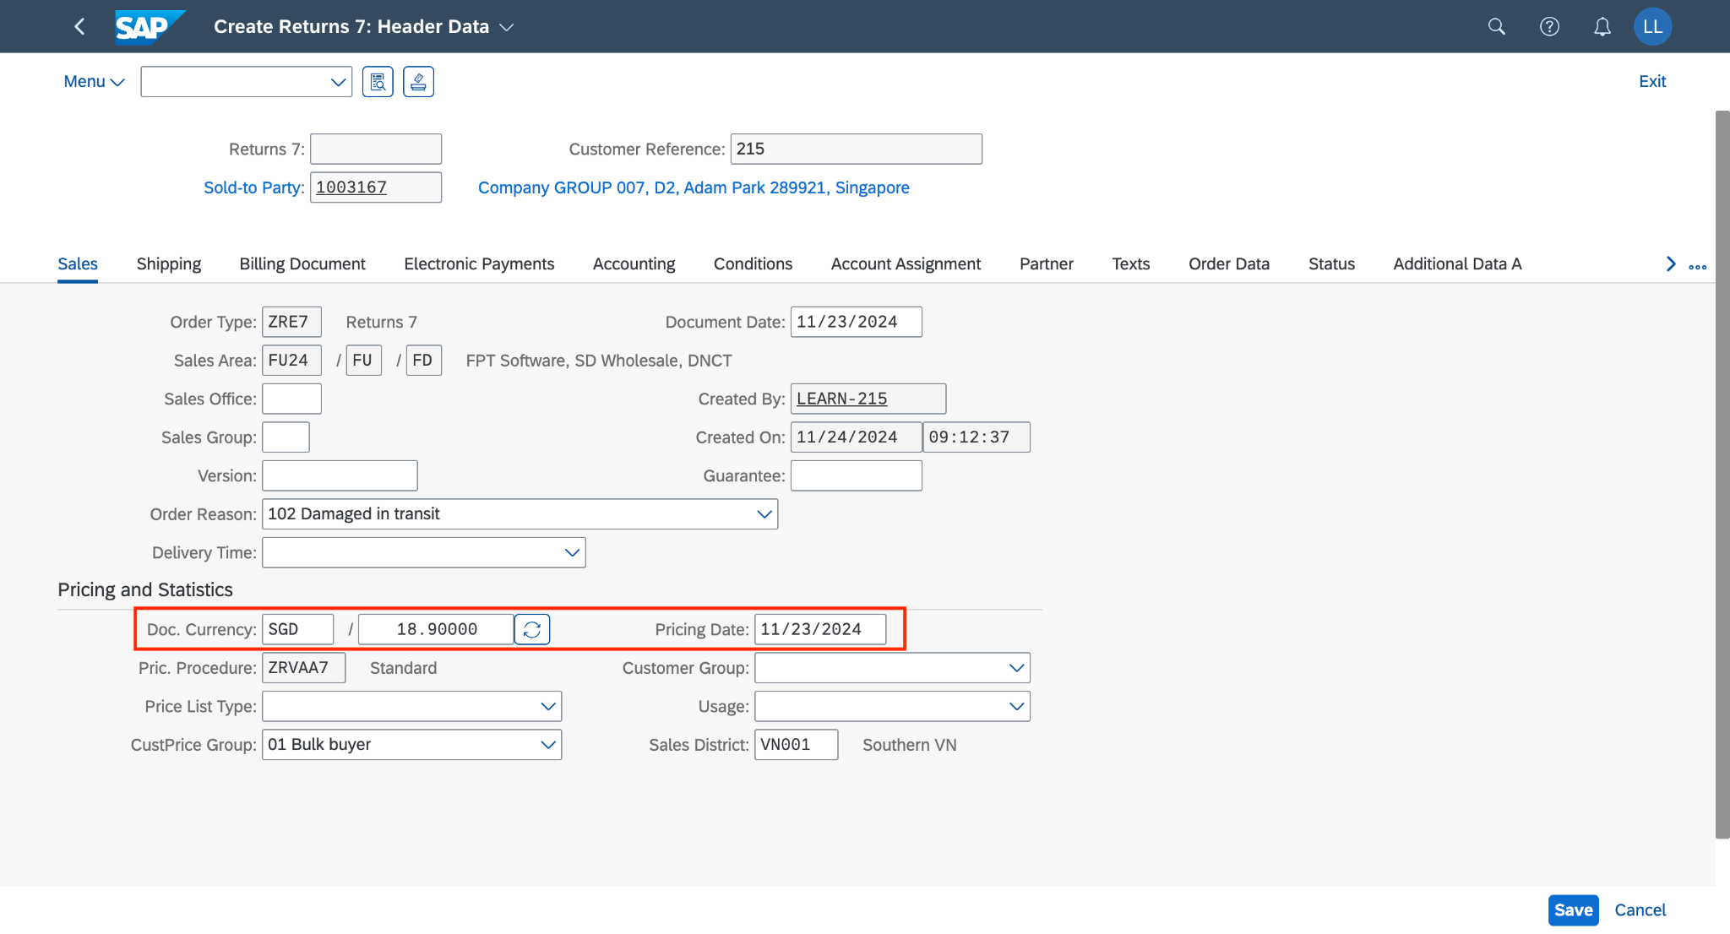

The data is taken exactly from this table:

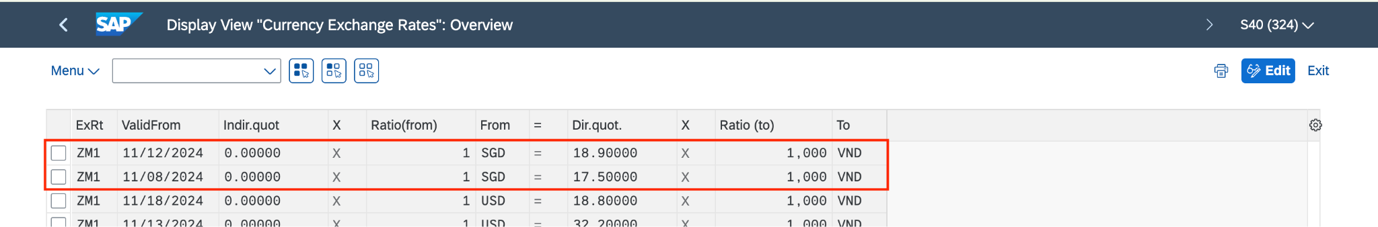

**(You can display this table in T-code OB08)**

Choose and write down the number of your returns order.

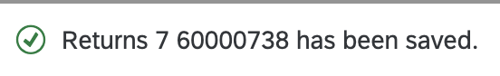

Click on  to return to the SAP Fiori launchpad.

## 2.3 Create Return Delivery

### 2.3.1 Transaction Code

| **T-code** | **Description** |
| --- | --- |
| VL01N | Create Outbound Delivery with Order Reference |
| VL02N | Change Outbound Delivery |
| VL03N | Display Outbound Delivery |

### 2.3.2 Detail Implementation

In the space *Sales and Distribution*, and in the section *Warehouse Employee*, please use the *Create Outbound Deliveries – From Sales Orders* app. Click on the application.

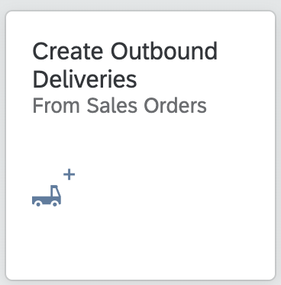

On the *Create Outbound Deliveries* screen, in the *Ship-to party* field please enter **your business partner number (1003167).**

In addition, as *Shipping Point* please enter **FU24**, and remove the *Planned Creation Date*. Click on to run the search. The returns order will be displayed.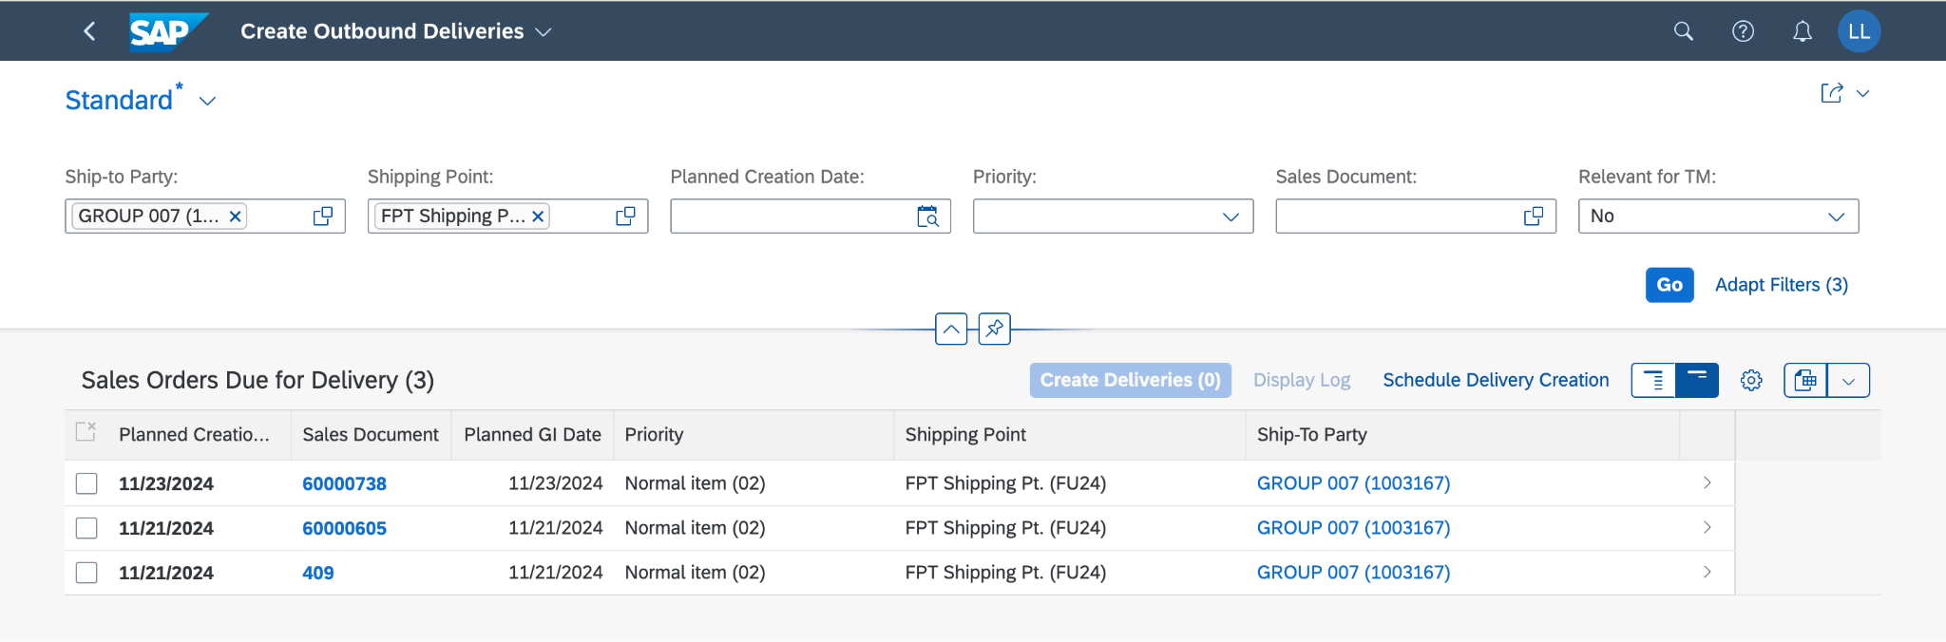

Select the sales document and choose the button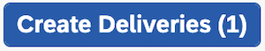.

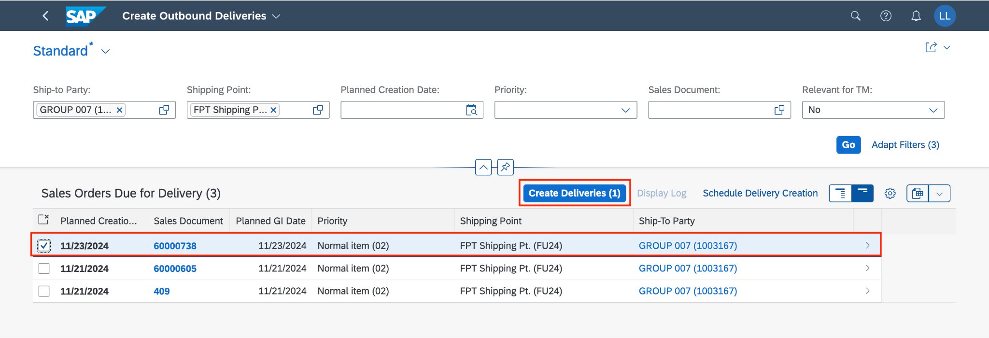

You will see that the sales document is no longer available. Additionally, you will receive confirmation that your outbound delivery has been created.

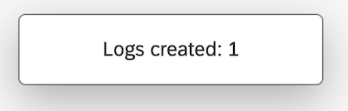

Click on  to return to the SAP Fiori launchpad.

## 2.4 Post Goods Receipt

### 2.4.1 Transaction Code

| **T-code** | **Description** |
| --- | --- |
| VL02N | Change Outbound Delivery |

### 2.4.2 Detail Implementation

Please use the Manage Outbound Deliveries app in the *Sales and Distribution space* and the *Warehouse Employee* sec*tion*. Click on the application.

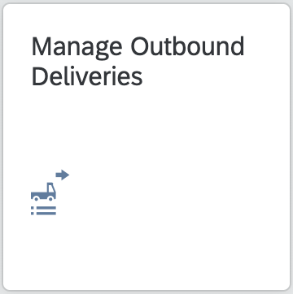

As the *Shipping Point* enter **FU24,** as*Ship-to Party*enter **1003167** and as *Overall Status* select **All Open Deliveries**. To run the search, click on . Your outbound delivery is now displayed.

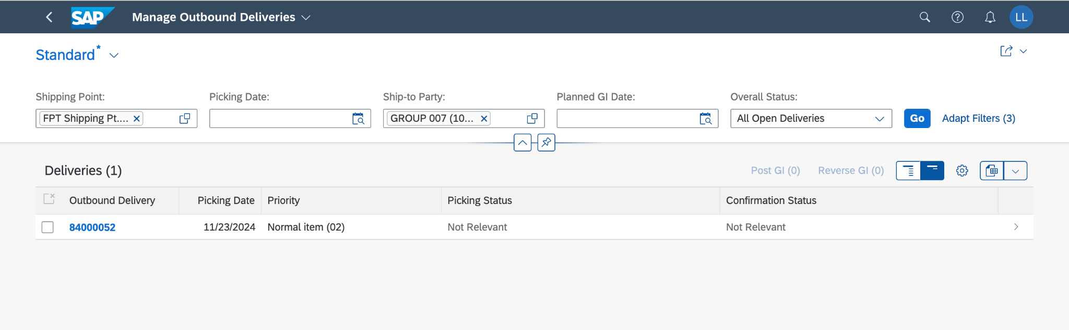

Click on the line that contains your outbound delivery if you want to get more details.

Select the outbound delivery and choose 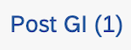.

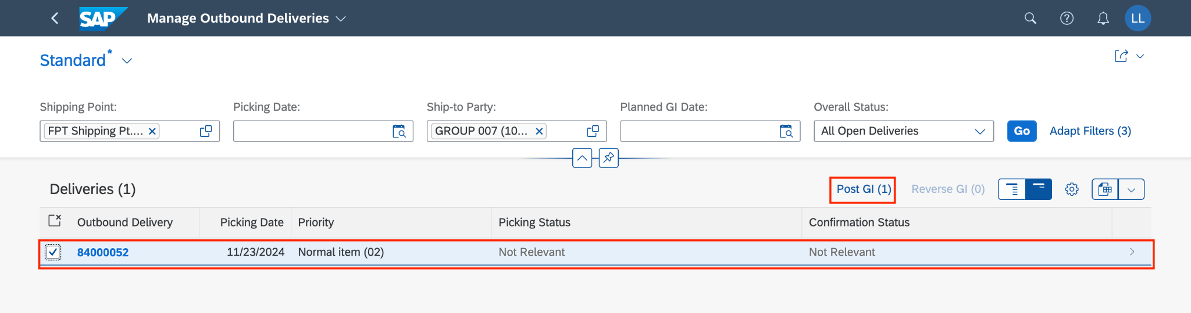

You can see the Post Goods Issue announcement, by choosing  .

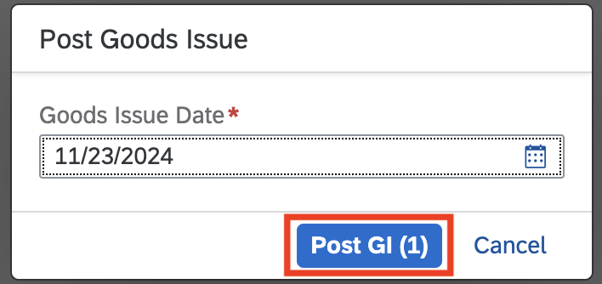

You will receive a confirmation 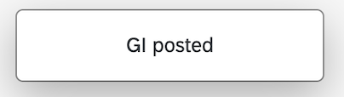. Post Goods Receipts are completed now.

Click on  to return to the SAP Fiori launchpad.

## 2.5 Remove Billing Block

### 2.5.1 Transaction Code

| **T-code** | **Description** |
| --- | --- |
| VA02 | Change Sales Documents |

### 2.5.2 Detail Implementation

In the space *Sales and Distribution*, and in the section, the *Sales Representative*, please use the app *Manage Sales Orders* to remove the billing block. Click on the application.



On the *Manage Sales Orders* screen,as*Sold-to Party*enter **1003167,** as *Customer Reference* enter **215** (your three-digit number **###**), and as *Overall Status* choose **In process**. To run the search, click on .

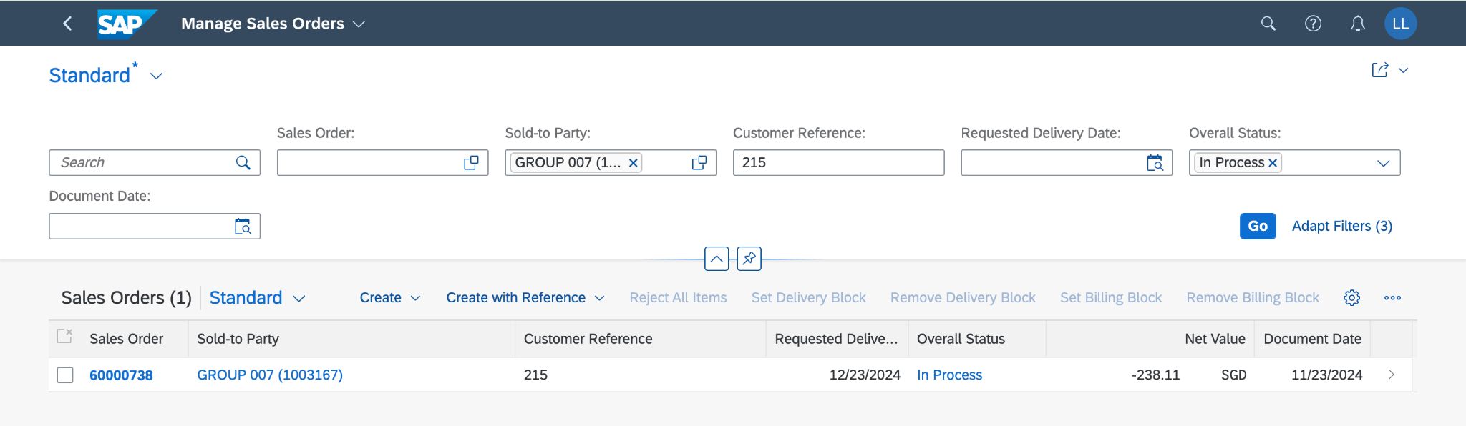

Select the returns order and click on 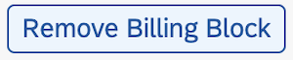.

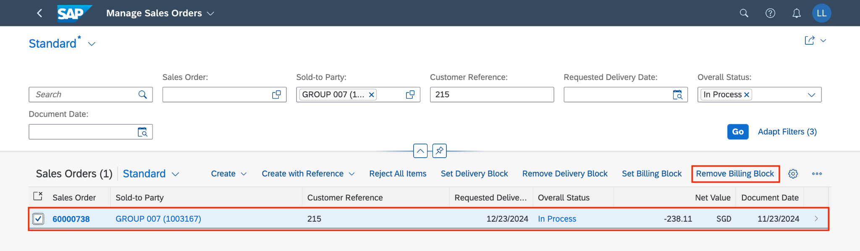

You will receive a confirmation your return has been saved. Remove Billing Block is completed now.

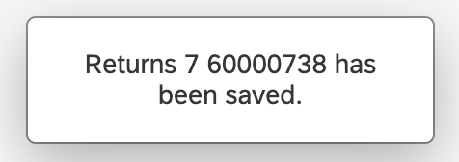

Click on  to return to the SAP Fiori launchpad.

## 2.6 Create Credit Memo

### 2.6.1 Transaction Code

| **T-code** | **Description** |
| --- | --- |
| VF01 | Create Billing Documents |
| VF02 | Change Billing Documents |
| VF03 | Display Billing Documents |

### 2.6.2 Detail Implementation

*(*Note: Please use the T-code for this step)*

In the  search field, enter **VF01** anduse the app *Create Billing Documents - VF01* to create a credit memo. Click on T-code **VF01** - Create Billing Documents.

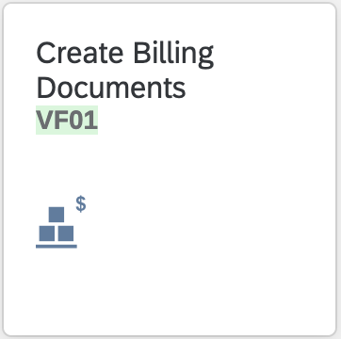

On the *Create Billing Document* screen, in the *Document* field, enter **your returns order number** **60000738**, then click on .

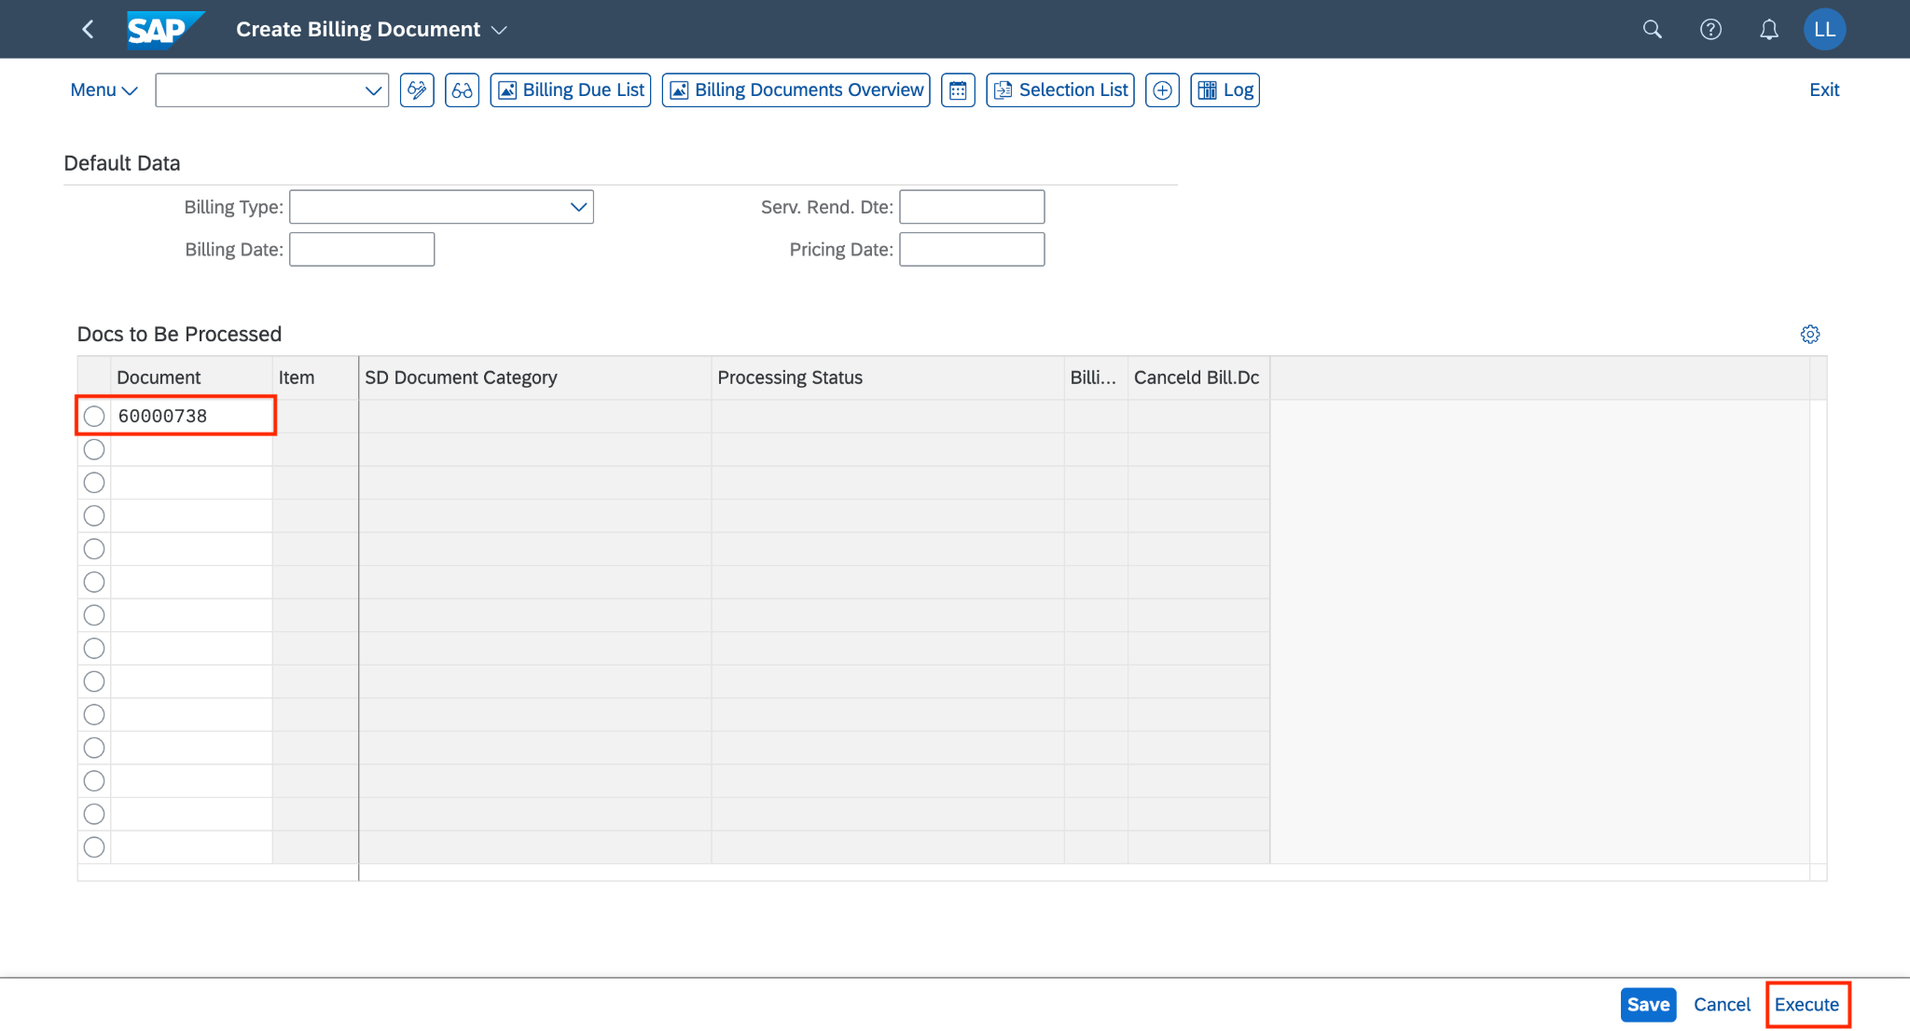

On the *Credit for Returns (RE) Create: Overview of Billing Items* screen, click on the symbol  (*Display header details)*.

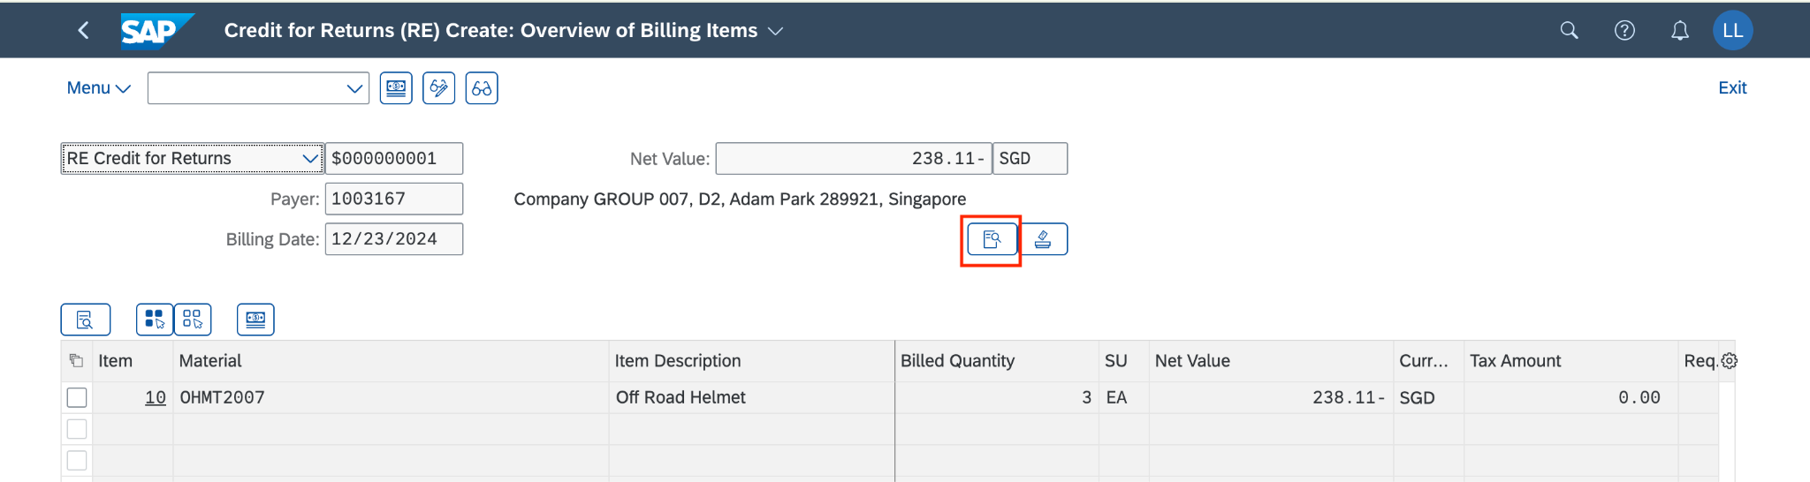

Now, on the *Billing Credit for Returns (RE) Create: Header Data* screen, you can view the *Billing Date* (**12/23/2024**) and *Exchng. Rate Accntg* (**18.90000**) is updated directly from the table in T-code OB08.

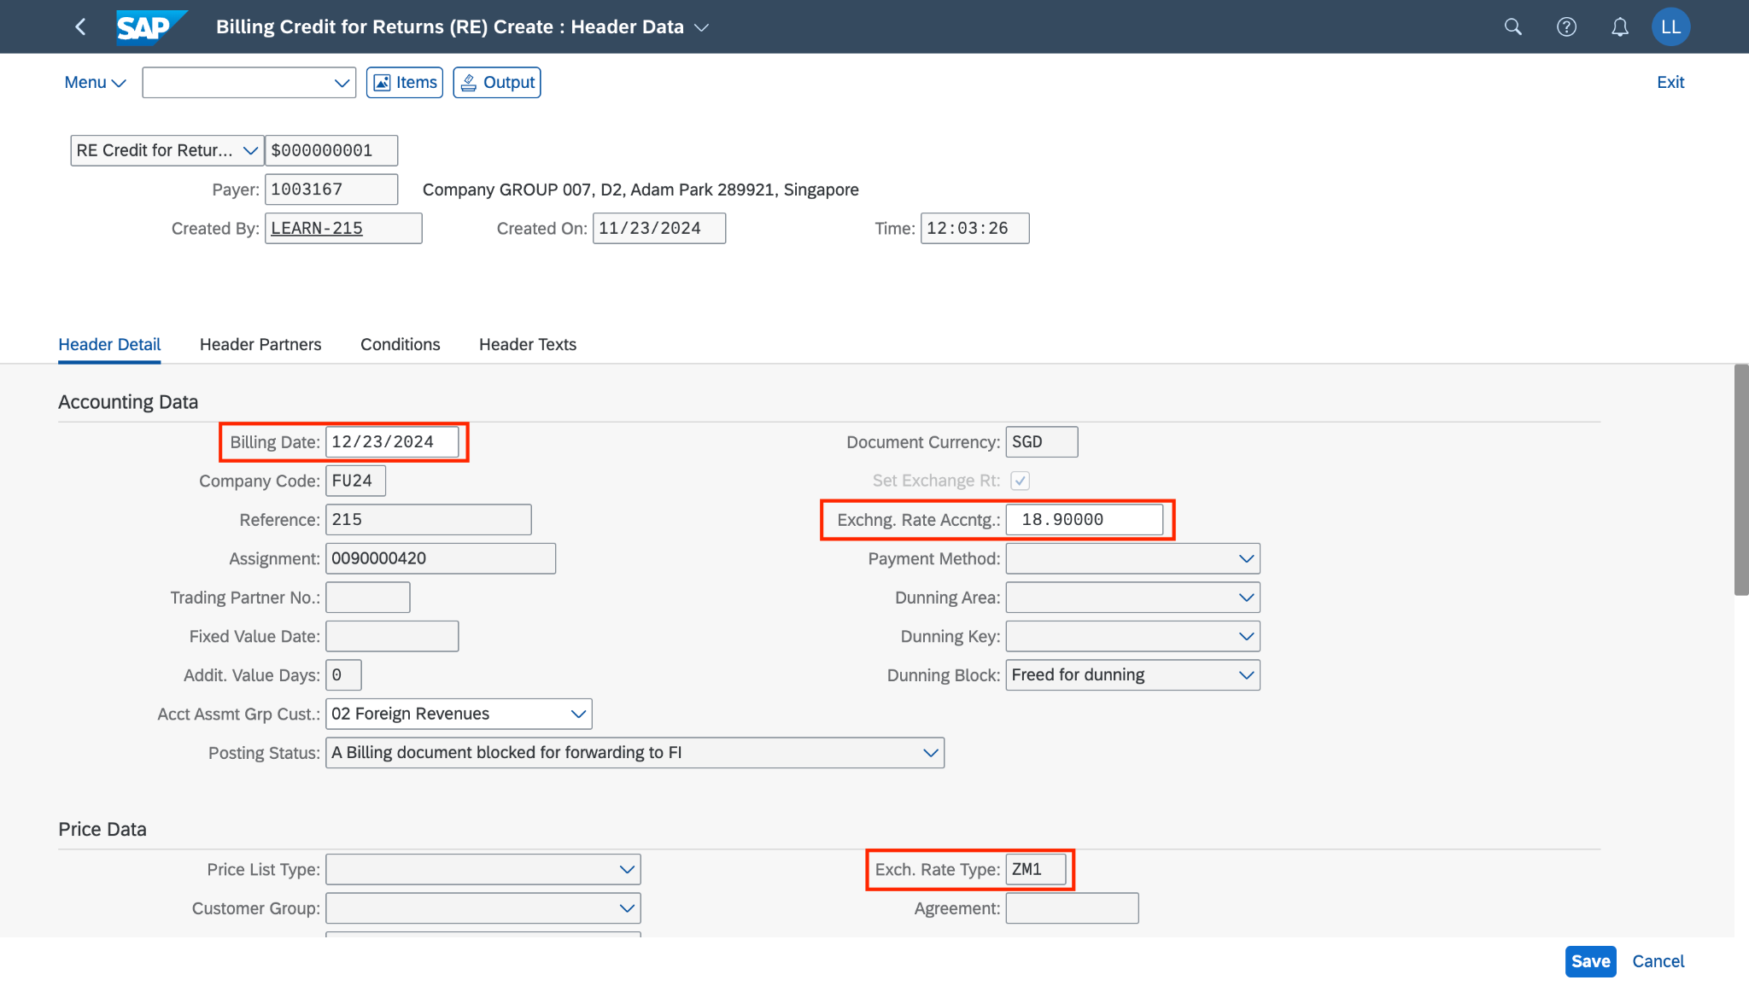

The data is taken exactly from this table:



**(You can display this table in T-code OB08)**

Change the *Billing Date* to **11/08/2024**,then press *Enter*. The *Exchng. Rate Accntg.* field will update from the table above with the message to notify that your exchange rate has been changed.

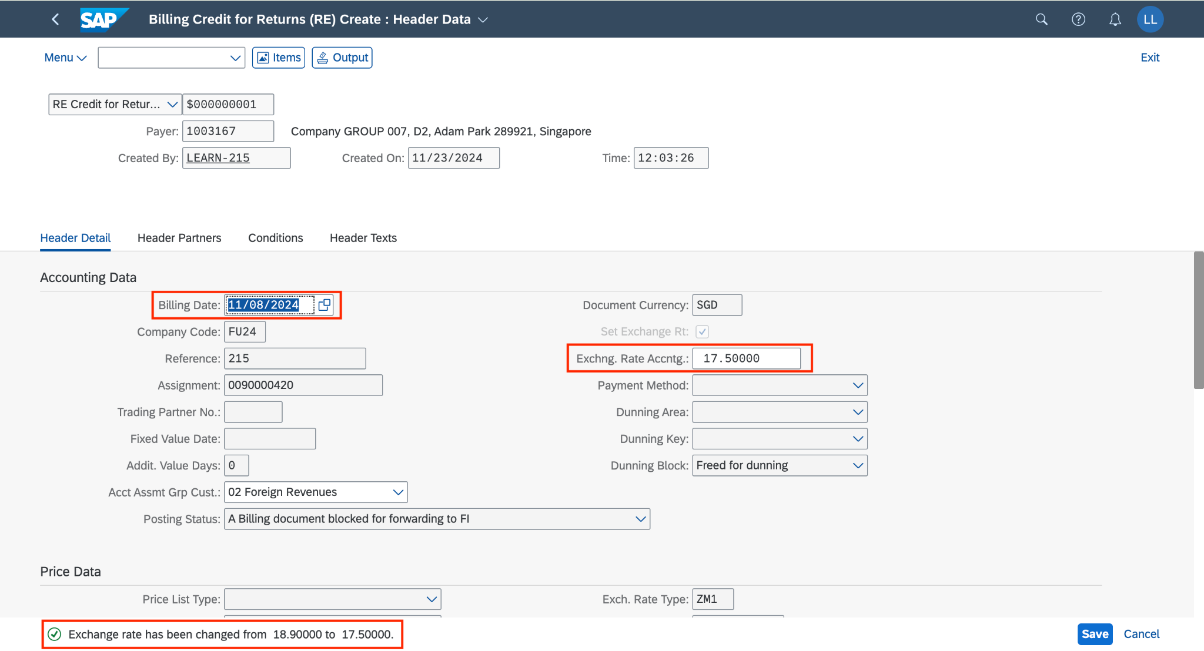

Additionally, the *exchange rate field* is editable so you also can change it to any random values.

Now change the *Billing date* back to **12/23/2024** and the exchange rate value has been updated.

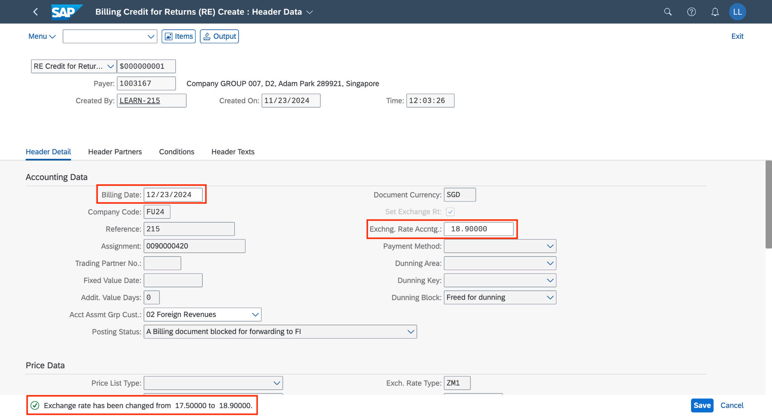

Choose to save the billing documents. The system will automatically assign a number to it.

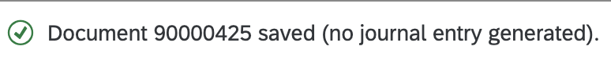

Click on  to return to the SAP Fiori launchpad.

## 2.7 Post Credit Memo & Display Accounting Documents

### 2.7.1 Transaction Code

| **T-code** | **Description** |
| --- | --- |
| VF02 | Change Billing Documents |
| VF03 | Display Billing Documents |

### 2.7.2 Detail Implementation

*(*Note: Please use the T-code for this step)*

In the  search field, enter **VF02** anduse the app *Change Billing Documents* to post a credit memo. Click on the application.

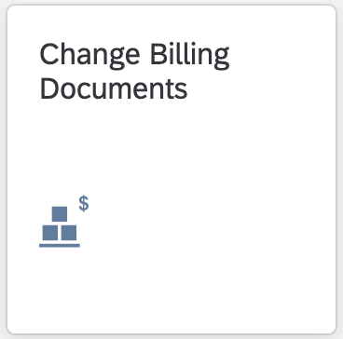

On the *Manage Billing Documents* screen, enter **your billing document number (90000425)**.

Then click (*Release to Accounting*) to post the billing documents.

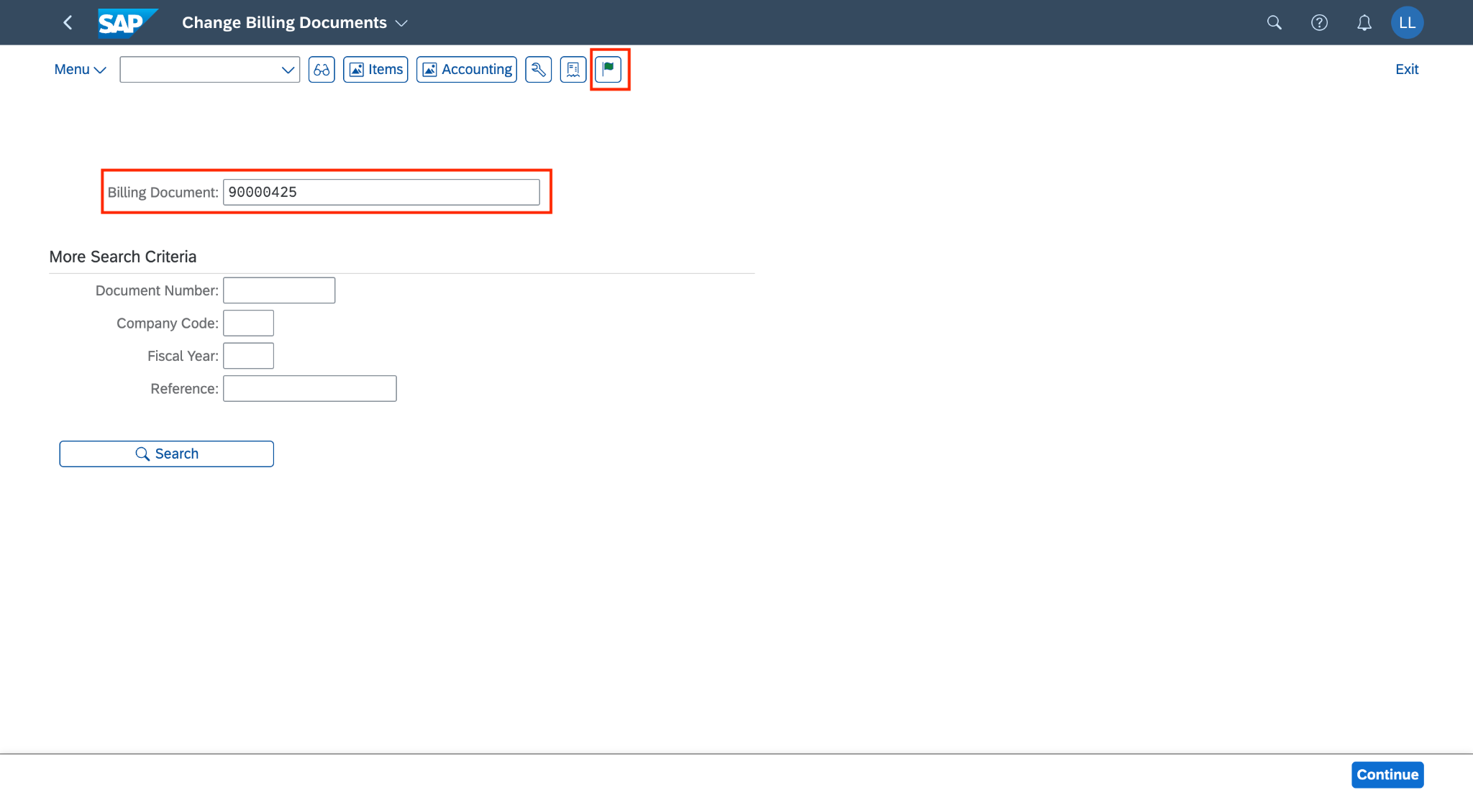

You will receive a notification that the billing document has been posted.

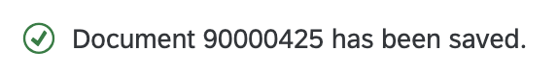

Then click 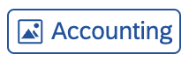to display the accounting document.

On the *List of Documents in Accounting* pop-up, choose the line *Accounting Document* and click on *(Display Document F2)*.

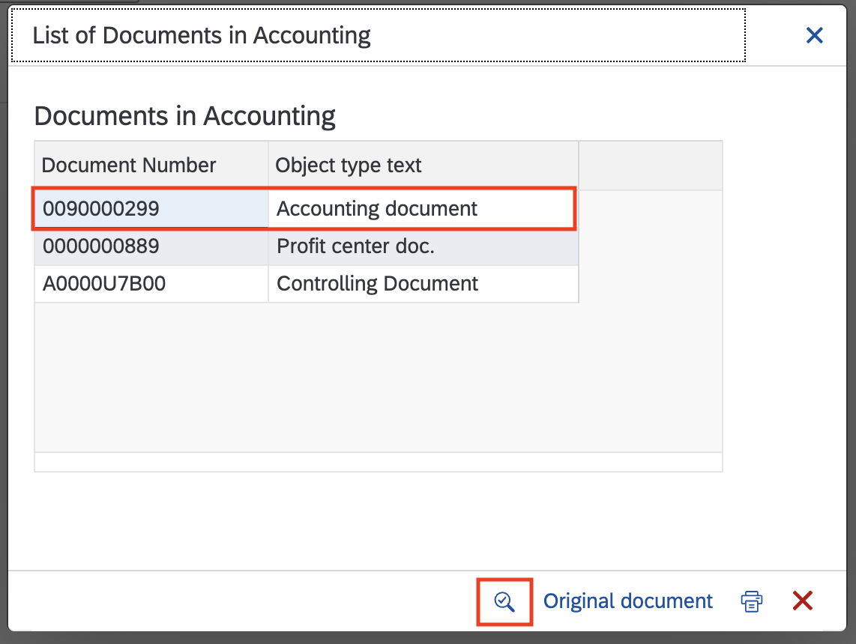

On the *Display Document: Data Entry View* screen, choose **to display the accounting document.

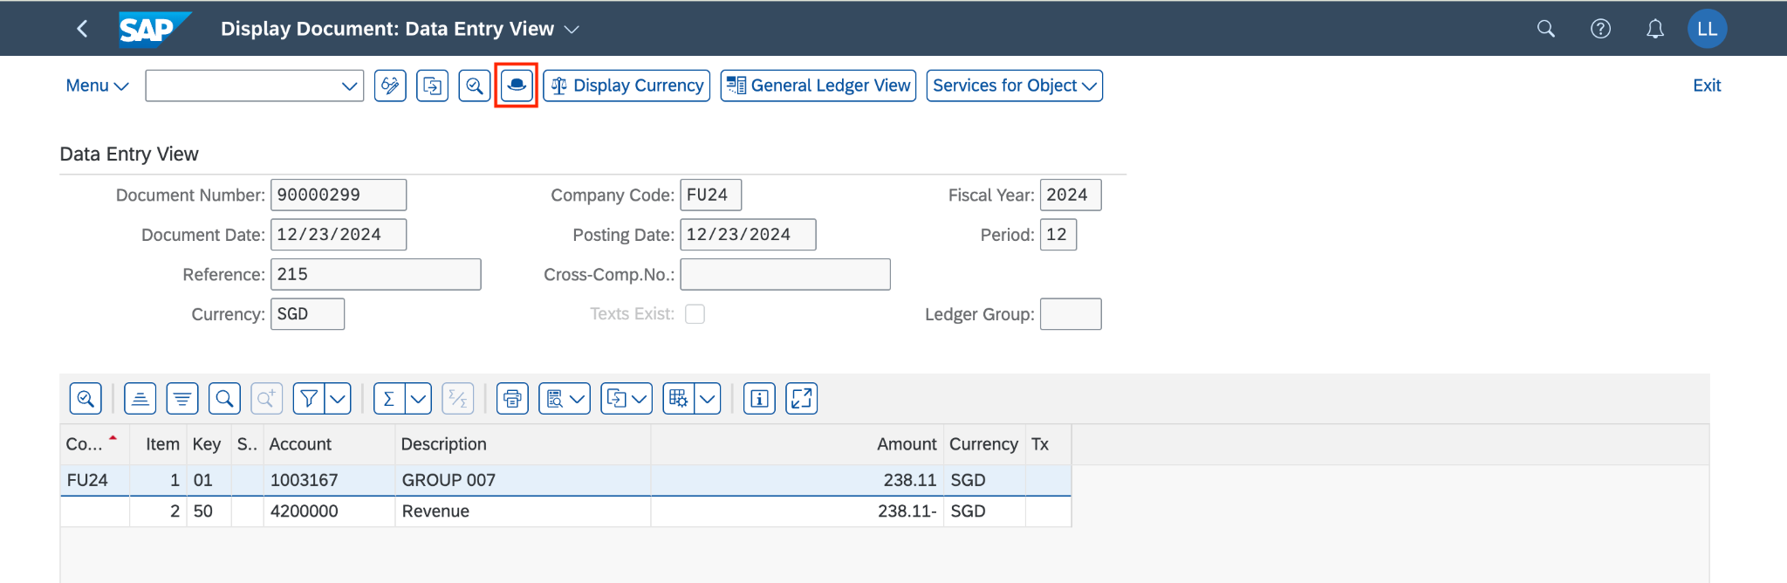

The *Document Header: FU24 Company Code* screen will pop out.

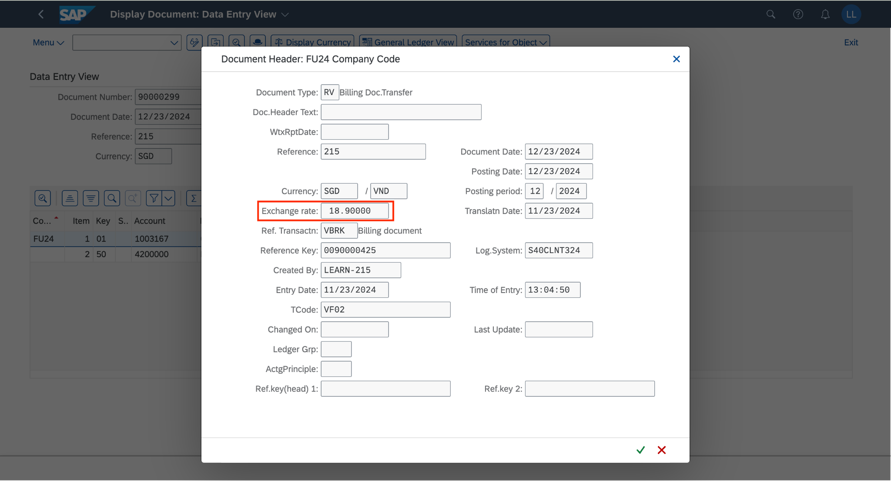

Now, you can view the *Exchange rate* field as **18.90000**. This value is updated correctly from the *Billing Header* in the *Create Billing Documents* step.

Click on  to return to the SAP Fiori launchpad.

## 2.8 Change Credit Memo

*(*Note: This step is processed in case Billing Documents - VF01 hasn’t been posted yet)*

### 2.8.1 Transaction Code

| **T-code** | **Description** |
| --- | --- |
| VF02 | Change Billing Documents |

### 2.8.2 Detail Implementation

*(*Note: Please use the T-code for this step)*

Before changing the billing document, the screenshot below shows that the billing document number we will use has not been posted in the journal entry.

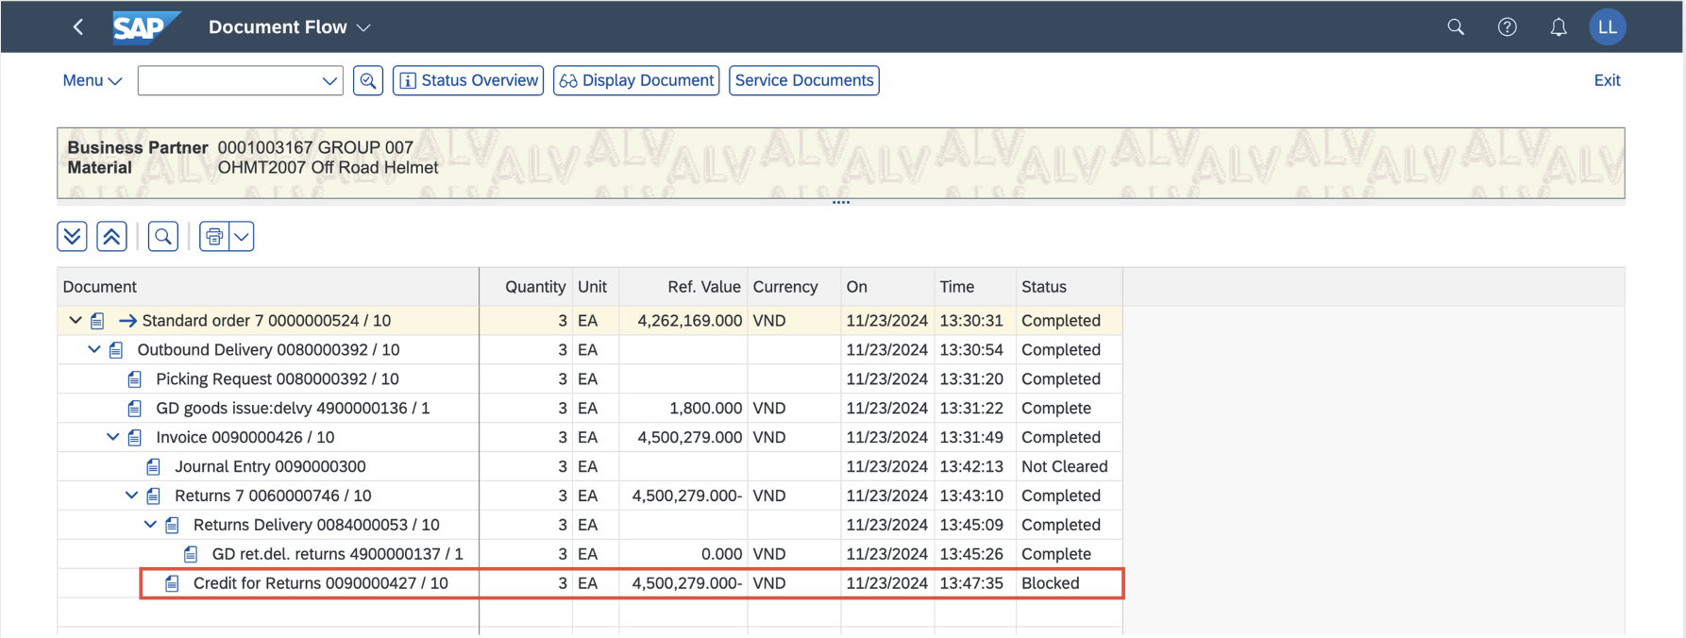

In the  search field, enter **VF02** and use the app *Change Billing Documents* to post a credit memo. Click on T-code **VF02** - Change Billing Documents.

### 

On the *Change Billing Documents* screen, enter **your billing documents number** that has not been posted **90000427**. Click on (or press *Enter).*

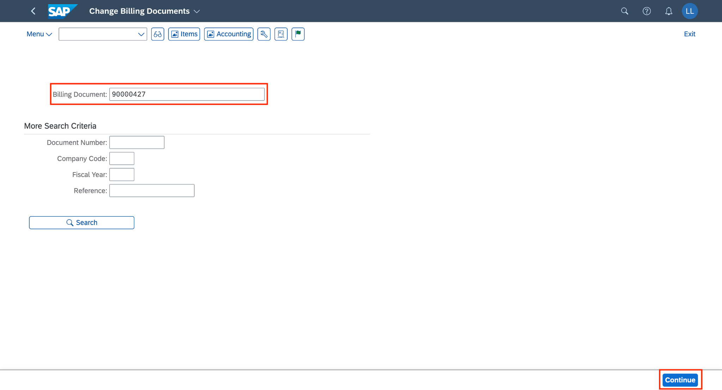

On the *Credit for Returns 90000427 (RE) Change: Overview of Billing Items* screen, click on  (*Display header details*) to display and change the billing documents.

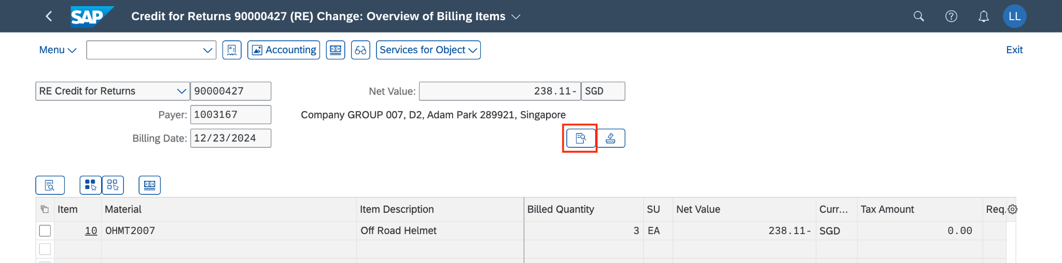

Now, you can see the *Exchng. Rate Accntg.* field as **18.90000**

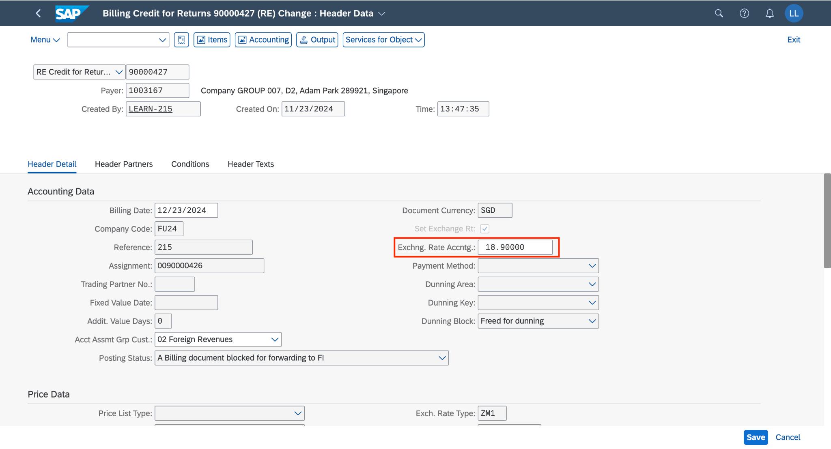

Change the *Exchng. Rate Accntg.* field from **18.90000** to **20.90000,** then click onto save the change.

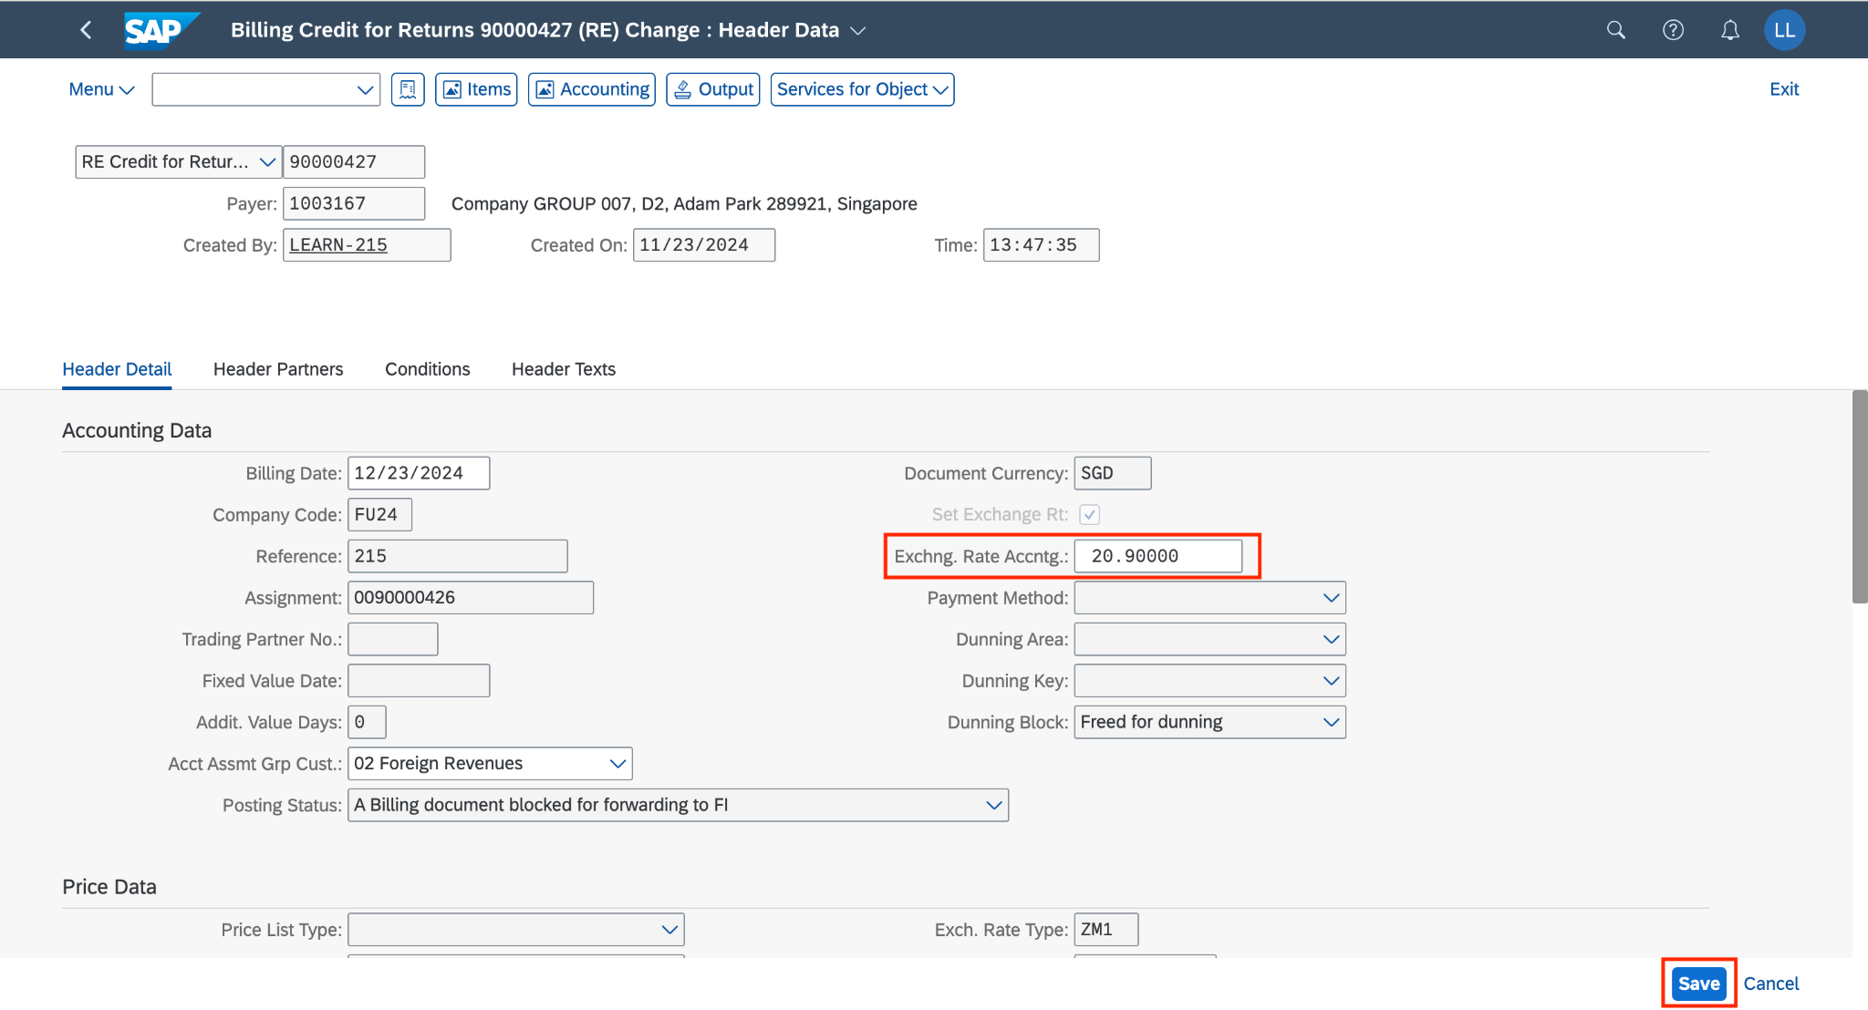

Click if you get this message:

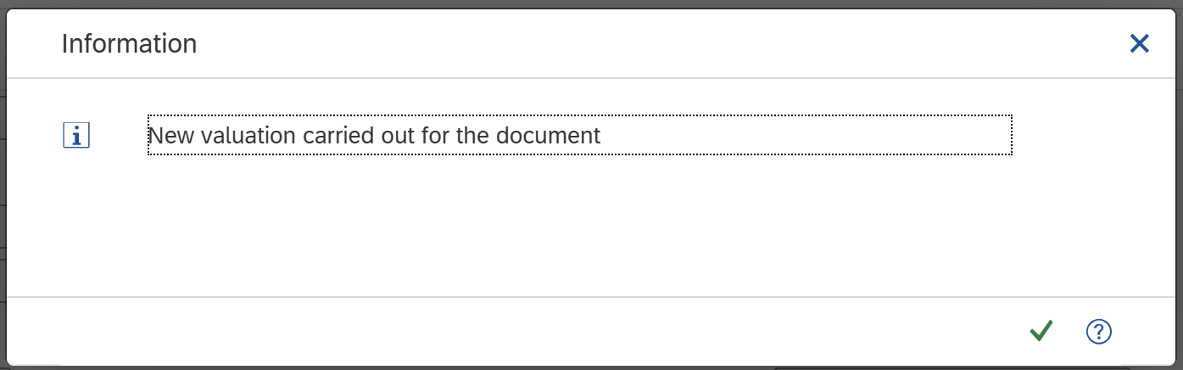

Now your billing document has been changed and you receive a message.

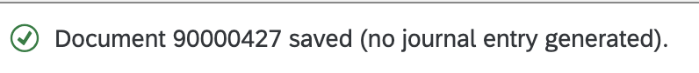

Click on  to return to the SAP Fiori launchpad.

## 2.9 Post Credit Memo & Display Accounting Documents

### 2.9.1 Transaction Code

| **T-code** | **Description** |
| --- | --- |
| VF02 | Change Billing Documents |
| VF03 | Display Billing Documents |

### 2.9.2 Detail Implementation

*(*Note: Please use the T-code for this step)*

In the  search field, enter **VF02** anduse the app *Change Billing Documents* to post a credit memo. Click on the application.



On the *Change Billing Documents* screen, enter **your billing document number** (**90000427)**.

Then click (*Release to Accounting*) to post the billing documents.

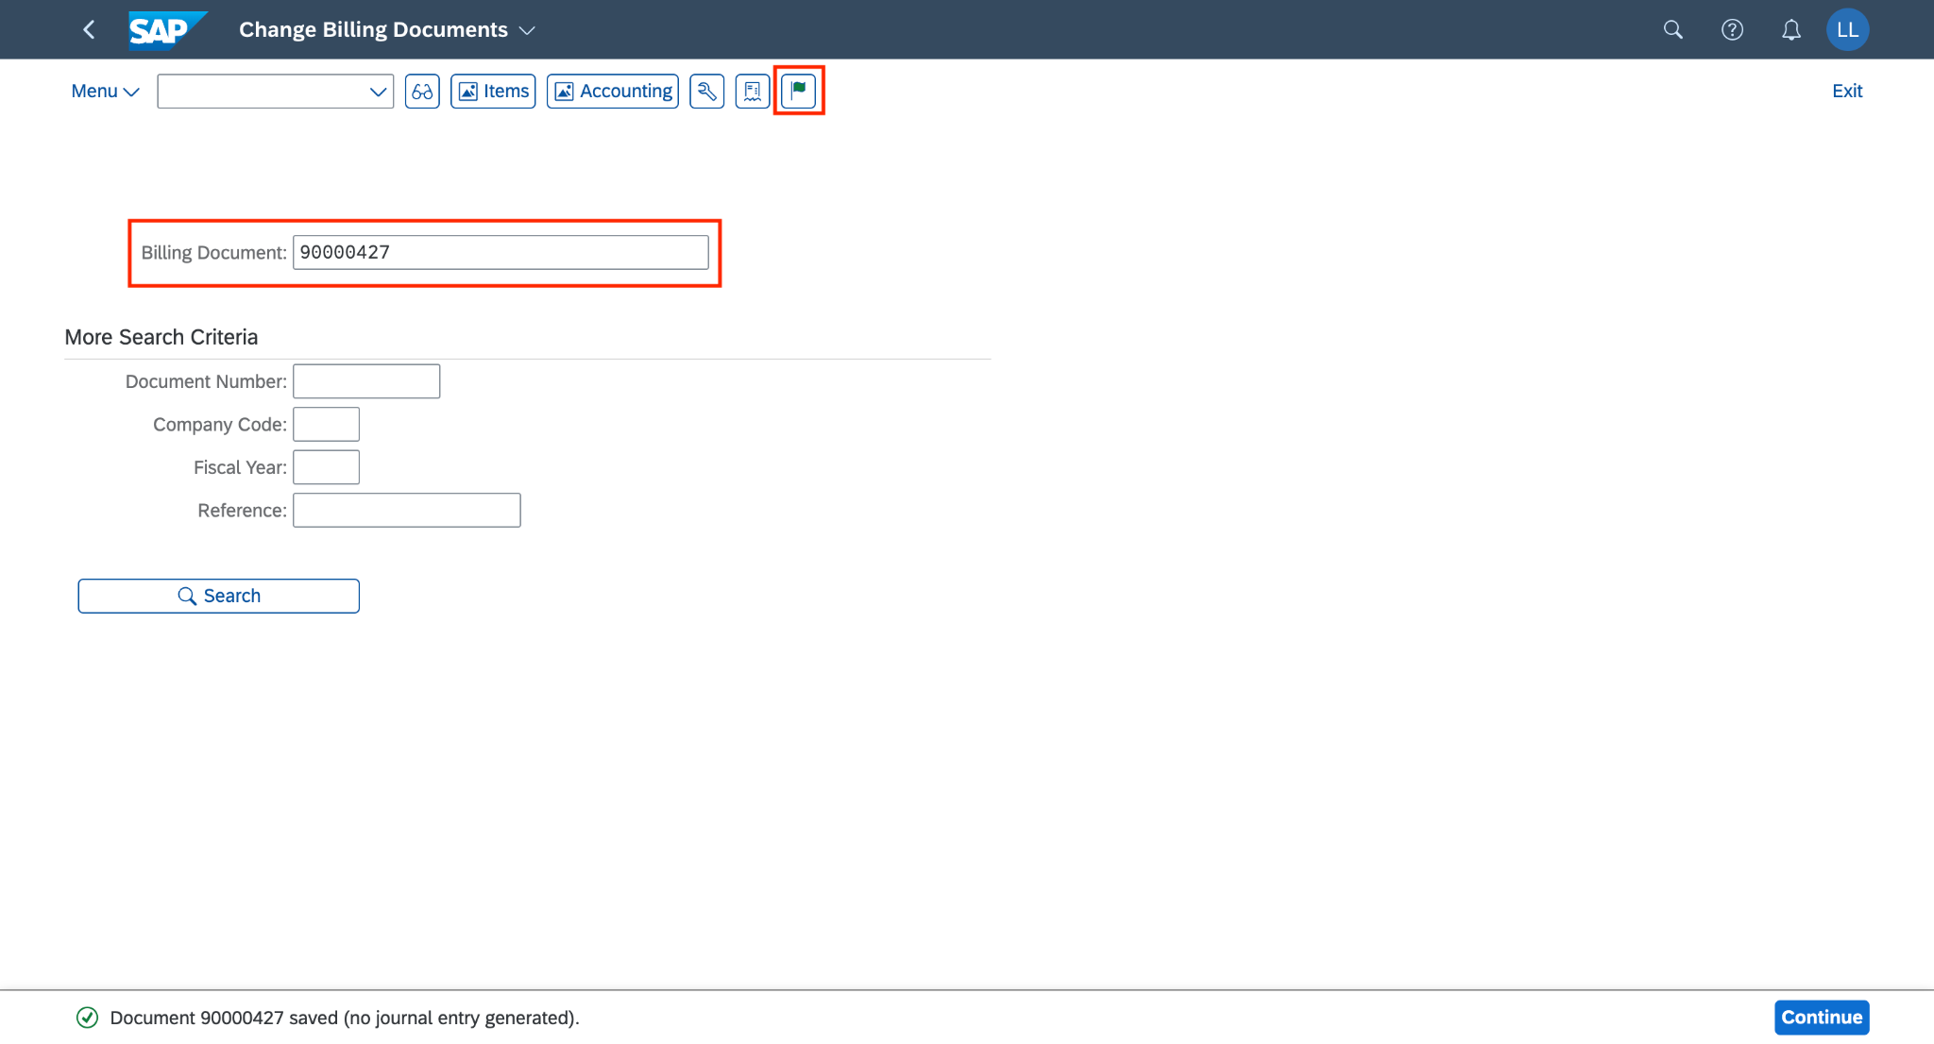

You will receive a notification that the billing document has been posted.

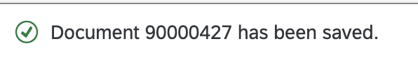

Click to display the accounting document.

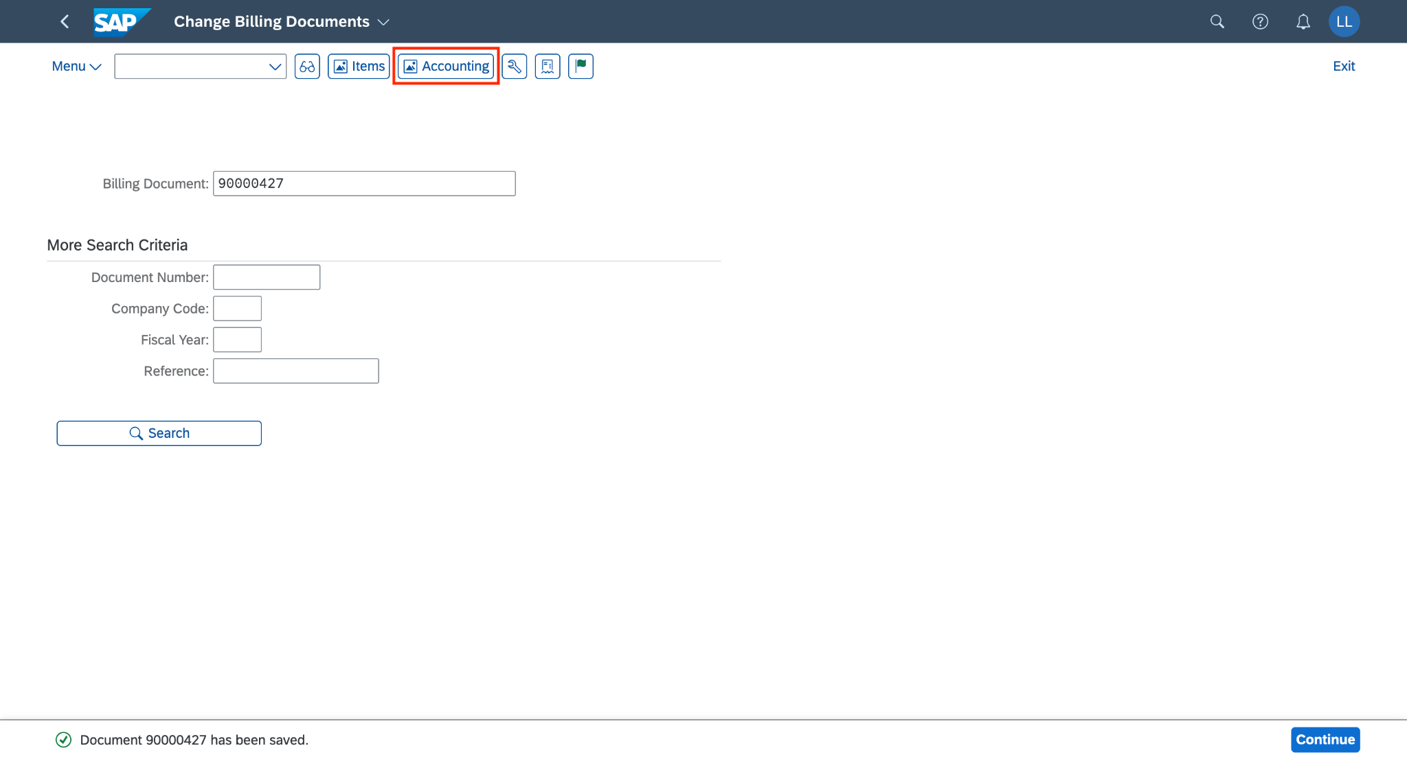

On the *List of Documents in Accounting* pop-up, choose the line *Accounting Document* and click *(Display Document F2)*.

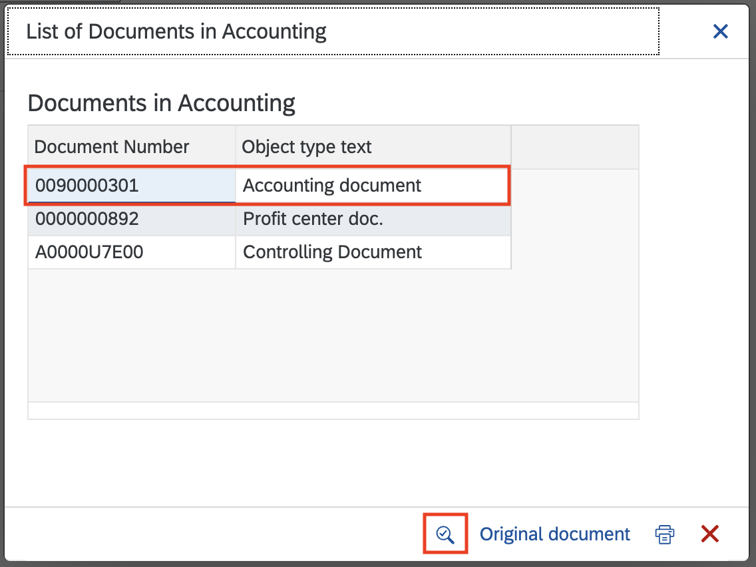

On the *Display Document: Data Entry View* screen, choose *Display Document Header (F5)* to display the accounting document.

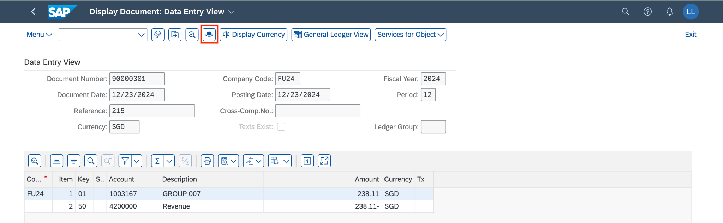

The *Document Header: FU24 Company Code* screen will pop out.

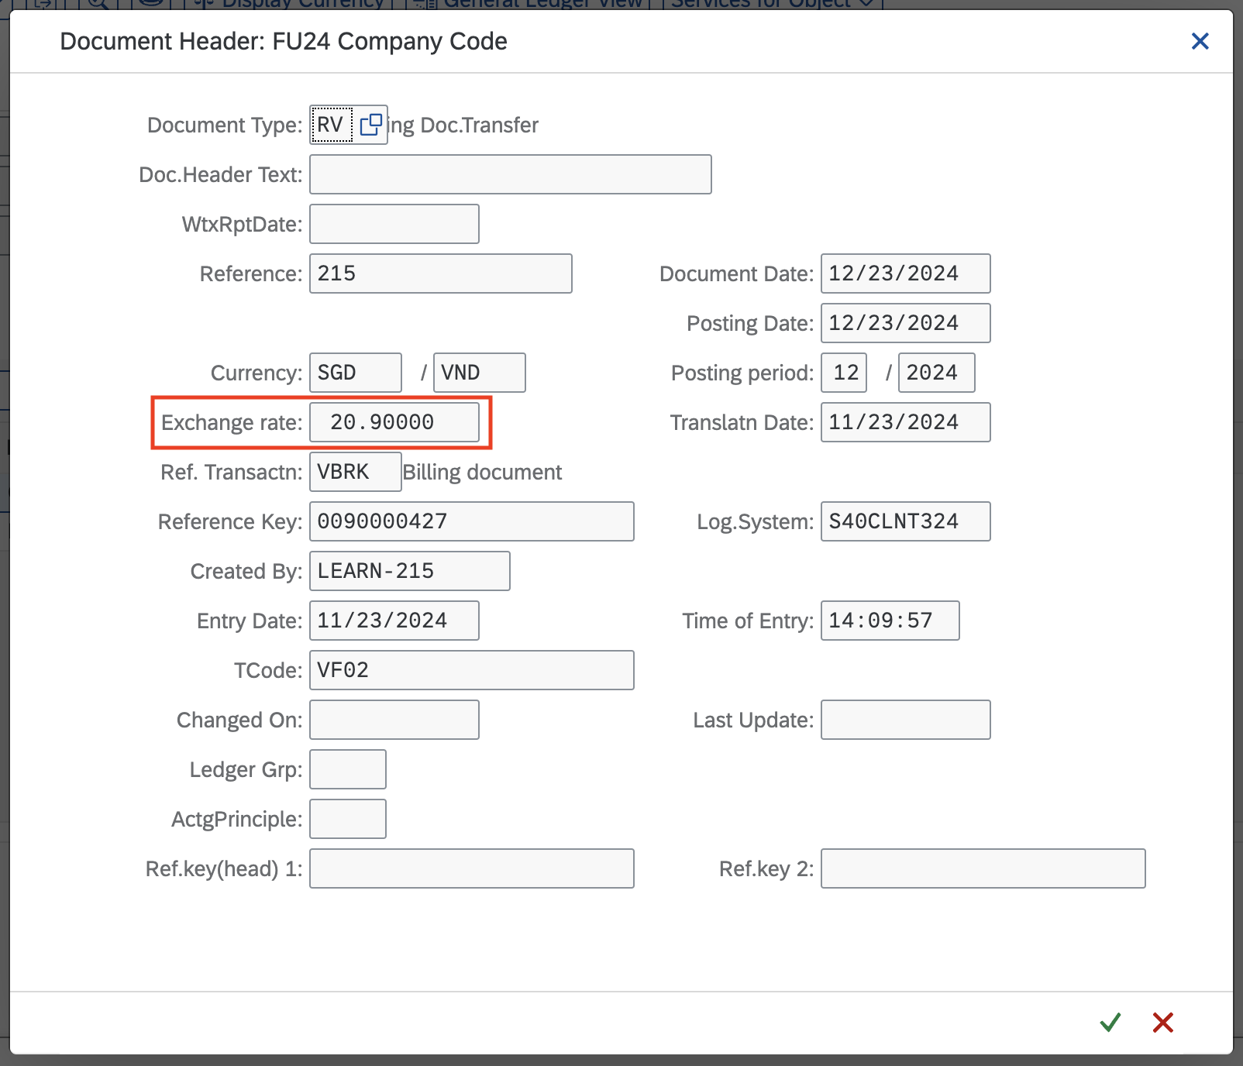

Now, you can view the *Exchange rate* field as **20.90000**. This value is updated correctly from the *Billing Header* in the *Change Billing Documents - VF02* step.

Click on  to return to the SAP Fiori launchpad.

### 